Unit 2: Biochemistry Study Guide
Vocabulary:
Define the following words on a separate sheet of paper.

Hydrogen Bond Monomer Enzyme
Acid Polymer Substrate
Base Polypeptide Active Site
Buffer Polysaccharide Activation Energy
Metabolism Covalent Bond Ionic Bond

Short Answer:
1. Indicate whether or not the following pHs would be considered a weak acid or base, a strong acid or base, or neutral.

____________________________ 2 ____________________________ 7 ______________________________ 6
____________________________ 8 ____________________________12

2. Acids release ________________________ ions in solution.
3. Bases release ________________________ ions in solution.
3. The left side of the arrow lists the __________________________________ in a chemical reaction.
4. The right side of the arrow lists the _________________________________ in a chemical reaction.
5. Organic molecules contain _________________________ atoms.
6. One carbon atom can make ______________ bonds with other atoms.
7. Fill in the table below
Polymer | Monomer | Function(s) | Elements Found In It
Carbohydrates
Lipids
Proteins
Nucleic Acids

8. What are some examples of the four macromolecules?

Carbohydrates –
Proteins –
Lipids –
Nucleic Acids –
9. How do monosaccharides differ from disaccharides?

10. After plants make glucose through photosynthesis, they can either store it for energy as ____________________________ or use it for structure to make cell walls as _______________________________.

11. Animals store excess glucose in their bodies in the form of _______________________________.

12. Why can’t lipids dissolve in water?

13. What is the difference between saturated and unsaturated fatty acid chains? (Hint: Think about bonds).

14. A triglyceride (aka lipid) consists of a _________________________ molecule attached to _______ fatty acid chains.

15. Proteins are by far the most DIVERSE organic compounds in the body. List as many functions of proteins as you can.

16. In a protein (aka polypeptide), amino acids are held together by a special type of covalent bond called a _________________________ bond.

17. What are the 3 main parts of a nucleotide?

18. What are the 2 types of nucleic acids?

19. What does an enzyme do to the rate of chemical reactions?

20. Which of the following organic compounds is an enzyme?
A) Carbohydrates B) Proteins C) Lipids D) Nucleic acids

21. Without knowing anything about their structure or function, how can you tell that lactase, fructase and protease are enzymes?

22. Which of the following would you expect to break down lactose?
A) Maltase B) Lipase
C) Lactase D) Protease

23. Label the parts of the reaction below using the terms enzyme, substrate, products, active site, ES complex.

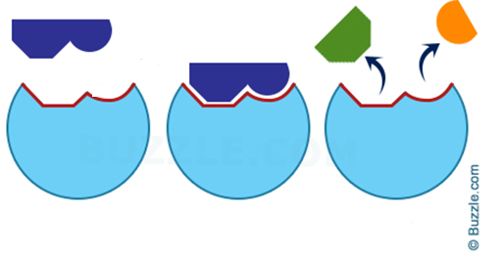
24. What two factors have the greatest impact on how well an enzyme functions?

25. Use the graph below to answer the questions:
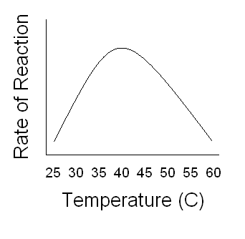
A. What is the optimum temperature for this enzyme?

B. What would happen if the reaction took place at 65°C?
26. Explain the “lock-and-key” model of enzymes being specific to substrates.

27. Complete the following table about testing for organic compounds.
Chemical Test | Compound Testing For | Positive Reaction Looks Like…
Benedict’s
Iodine/Lugol’s
Biuret
Brown Paper Bag

