Tyler Biology Midterm Study Guide
This study guide packet reviews the material covered in the first semester. To properly prepare for the exam you should:
- Complete and Review this packet
- Organize and Review your notes
- Look through past quizzes/graphic organizers/study guides
- Study a little bit each night—cramming will stress you out!!!
- Ask/email me with any questions or concerns you may have
Unit 1: Scientific Method and Characteristics of Life
- List the 7 characteristics of all living things:
1)
2)
3)
4)
5)
6)
7)

- What is biology?

- Define homeostasis and give an example.

- Define sexual and asexual reproduction.

Experimental Design:
Read the following experimental designs and answer the questions.
- A group of students was trying to determine which type of soil rose bushes would grow tallest in. They had five rose bushes that they planted in five different types of soil. The size of the pots was the same, they watered the plants the same amount, and they kept the plants in the same light and temperature conditions.

- What was the problem?

- What was the independent variable?

- What was the dependent variable?
- Kari has been doing research on a new chemical to help tomato plants grow and produce bigger, healthier tomatoes. She hypothesized that the new chemical would increase plant growth by producing larger tomatoes. Kari set up an experiment in a greenhouse with the same species of tomatoes in five small pots. One pot did not receive any fertilizer, while the other four pots got different amounts of fertilizer. She kept all conditions that same such as humidity, temperature, soil, amount of water, and amount of light. Her data is listed below.

Pot | Amount of fertilizer per day | Growth of Plant
1 | 0 mL | 3 inches
2 | 4 mL | 2 inches
3 | 6 mL | 5 inches
4 | 8 mL | 6 inches
5 | 10 mL | 9 inches

- Control Group? ______________________________________________________________
- Experimental Group(s)?_______________________________________________________
- Controlled Variables? _________________________________________________________
- Independent Variable? _______________________________________________________
- Dependent Variable? _________________________________________________________
- What is the purpose of the control group in this experiment? _________________________ ___________________________________________________________________________

- Describe Redi’s experiment to disprove spontaneous generation.

Unit 2: Biochemistry
- Write the letter (a-e) in the box that best corresponds to the statements below about pH.

- Strong base c. Weak acid E. Neutral
- Strong acid d. Weak base

- Label the following bonds as strong or weak:
Covalent bonds - ________________________
Hydrogen bonds - ________________________

- What is an organic compound? What element do they all contain?

- Fill in the table below.
Organic Compound | Monomer (subunit) | Function | Examples
Carbohydrate
Protein
Lipid
Nucleic Acid

- Identify the organic compound associated with each of the following structures: protein, carbohydrate, lipid, nucleic acid.
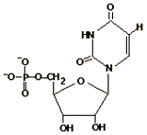
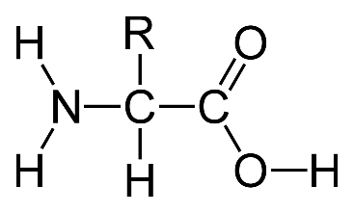
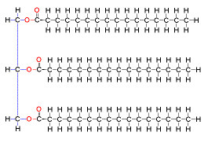

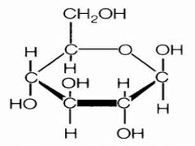

- What is an enzyme? Define the term catalyst in your answer.

- What do enzymes do to the rate of chemical reactions?

- What is meant when we say that enzymes work in a lock and key fashion? Can they bind to many different type of substrates?

- Label the diagram below with the following terms: active site, enzyme, products, substrate, enzyme-substrate complex).
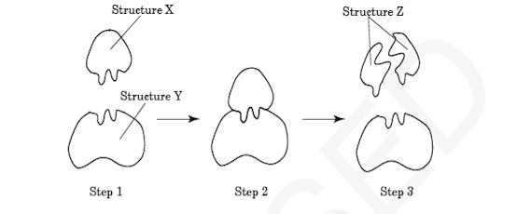
- Mark each statement as true or false:
_________ Enzymes cannot be reused (they are changed/used up in a chemical reaction)
_________ Enzymes are proteins
_________Enzymes work best within a certain optimal pH
_________Enzymes slow down the rate of chemical reactions
_________Substrates bind to enzymes at the active site

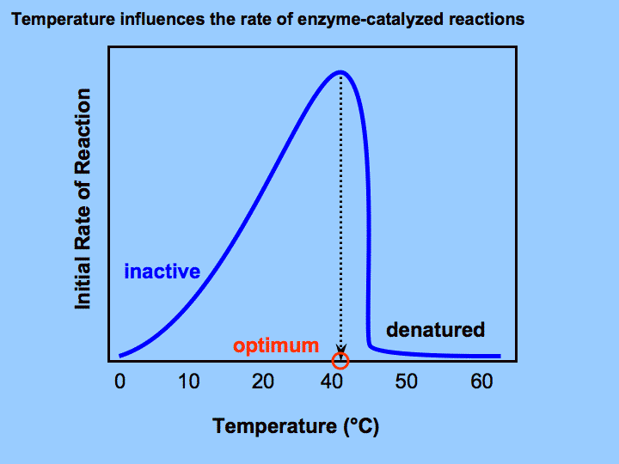
Use the graph to the left to complete the statement.
As the temperature gets (warmer or colder), enzymes will work better and better. If it gets too hot though, the enzyme will ________________________, losing its 3D shape. The optimal temperature for this enzyme is at __________°C. This is where the enzyme works best (reaches the maximum rate for the chemical reaction).

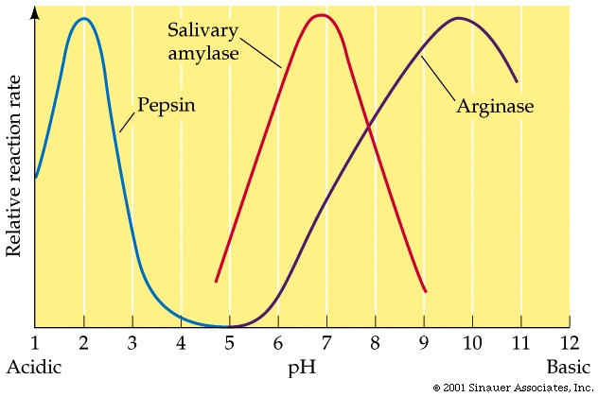
Use the graph to the left to complete the questions.
- The optimal pH for the enzyme pepsin is ___________.
- Does salivary amylase function at a pH of 9? If not, what has happened to it?

Enzymes are responsible for most metabolic processes in your body! They control digestion of food, photosynthesis, cellular respiration, DNA replication, transcription and translation, and even the cell cycle!!!

Unit 3: Cells/Cell Membranes

- What are the three parts of the cell theory?

- Compare and contrast prokaryotic and eukaryotic cells. What are the 2 main differences between them? What 4 cell structures do they have in common?
Differences:

Similarities:

- Classify each as a prokaryote (P) or eukaryote(E):
Bacteria _____ Animal _____ Plant ______ Fungi _____ Protist _______

- Name 3 differences between an animal and a plant cell.

- Matching: Next to each organelle, write the letter of its function.
_______mitochondria a. where proteins are made (site of protein synthesis)
_______cell membrane b. site of photosynthesis; contains the pigment chlorophyll
_______cell wall c. packages and ships materials out of or to different parts of the cell
_______golgi body d. stores water and nutrients; maintains turgor pressure in plants
_______nucleus e. provides support and protection for the plant cell
_______vacuole f. powerhouse of the cell; makes energy (ATP) during cell respiration
______chloroplasts g. control center of the cell; contains the genetic info
______ribosomes h. is selectively permeable; controls what goes in and out of the cell
______endoplasmic reticulum i. transport proteins and lipids around the cell

- Label the diagrams below
A.
B.
C.
D.
E.
F.
G.
H.
I.

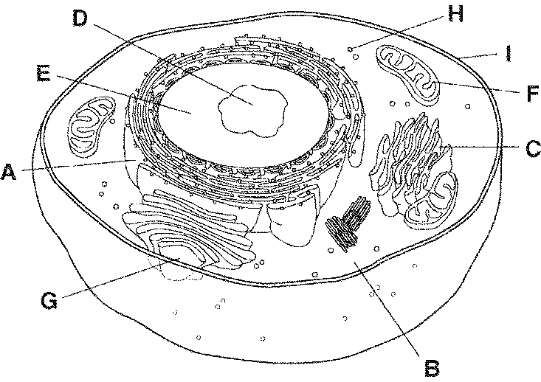

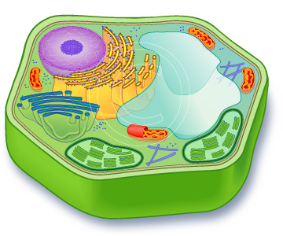
F
E
D
C
B
A
A.
B.
C.
D.
E.
F.

- What do we mean when we say that the cell membrane is selectively permeable?

- Label the parts of the cell membrane:

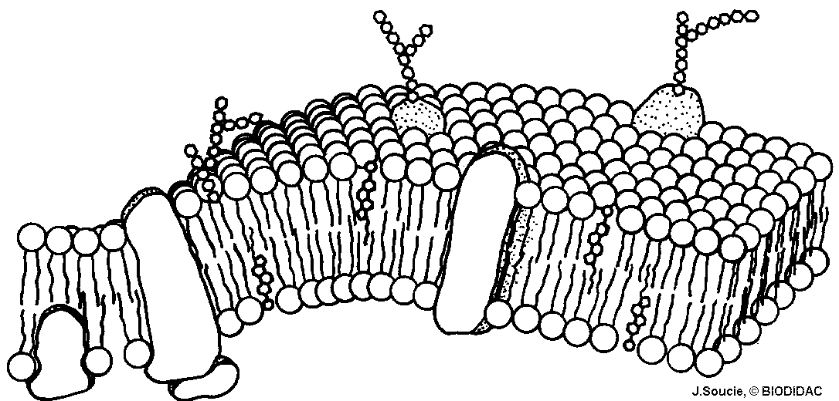
D
_______ phospholipid
_______ cholesterol
_______ protein
_______ carbohydrate
C
B
A

- The cell membrane is made up mostly of _______________________ in a bilayer. The __________________ that pass through the bilayer help transport large molecules into and out of the cell.

- In passive transport molecules move from ______ to ______ concentrations of solute, and it (does, does not require energy. In active transport, molecules move from ______ to ______ concentrations of solute, and it (does, does not) require energy).

- Name AND describe the three types of passive transport.

- Define osmosis.

- Define the following terms the LABEL each picture

- Hypertonic solution -
- Hypotonic solution -
- Isotonic Solution –

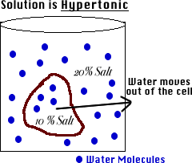
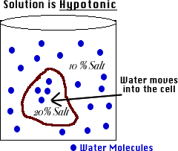
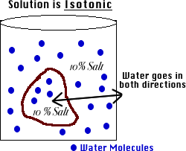

- While cleaning an aquarium, you take a freshwater plant and place it in saltwater.
A. What will happen to the size of the plant?
B. Which way will water move?
C. What type of solution is the saltwater?

- Name the three types of active transport.

- What is endocytosis and exocytosis?

- What is the difference between diffusion and active transport?

Unit 4: Photosynthesis and Cellular Respiration
- Define photosynthesis

- What is the equation for photosynthesis in words?

- In what organelle does photosynthesis occur?

- What is the name of the pigment that absorbs sunlight energy? ____________________

- During photosynthesis, the sunlight energy is converted into ________________ energy.

- What types of organisms carry out photosynthesis?

- What energy-containing molecule is made during cellular respiration that gives our cells the energy it needs to carry out all of its functions? ____________

- How do we release the energy from ATP?

How many phosphate groups does ATP have? ADP?

What are the circles with “P”s in them representing in the picture of ATP to the right?
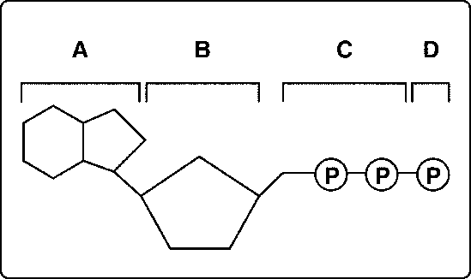

- What is the equation for cellular respiration in words?

- Aerobic respiration requires _________________________, but anaerobic respiration does not.

- What are the two types of anaerobic respiration (fermentation) and their products? In what types of organisms/cells would each occur?
a.

b.

- Which type of respiration produces the most ATP (is most efficient)?

- In what organelle does cellular respiration occur?
- What types of organisms carry out cellular respiration?

- True or False. The products of photosynthesis are the reactants of cellular respiration, and vice versa.
Unit 5: DNA/RNA/Protein Synthesis
- What are the two types of nucleic acids? ____________ and ___________

- A _______________ is a segment of DNA that codes for a protein

- A _____________________ is the subunit (building block) of DNA and RNA.

- Draw and label the parts of a nucleotide

- The shape of DNA is referred to as the “twisted ladder” or _____________ ________________. The sides (backbone) of the ladder are made up of ____________ and _____________________. The steps of the ladder are made of the ______________________ _______________.

- The nitrogen bases are held together by ________________ bonds.

- How are RNA and DNA different?

- Write the complementary strand of DNA:
DNA: G A C C T T A G C A
DNA: _________________________

- Identify each as a segment of DNA, RNA, or both (could be either).

- ATCT _________ b. AGGCU __________ c. UAUU ___________ d. AGGCA _________

- ______________________ is the process where DNA is copied into an identical DNA molecule. This occurs in the _________________________.

- ______________________ is the process where DNA is converted into mRNA. This occurs in the ___________________________.

- ______________________ is the process where mRNA is read 3 bases at a time (called _________) to form a protein. This occurs at the _____________________.

- ______________________ is a type of RNA that carries the genetic message of DNA into the cytoplasm for the ribosome read.

- ___________________________ is a type of RNA that brings amino acids to the ribosome for protein synthesis.

- _____ mRNA nucleotides = 1 codon

- What amino acids are coded for by the following mRNA strand? (Use the chart in your notes) AUG - CCC- ACU- GAU- UGA

- Use the section of DNA to figure out the amino acids that will be formed during protein synthesis.
DNA: A T G C G A

mRNA: _________________________

amino acids: _________________________

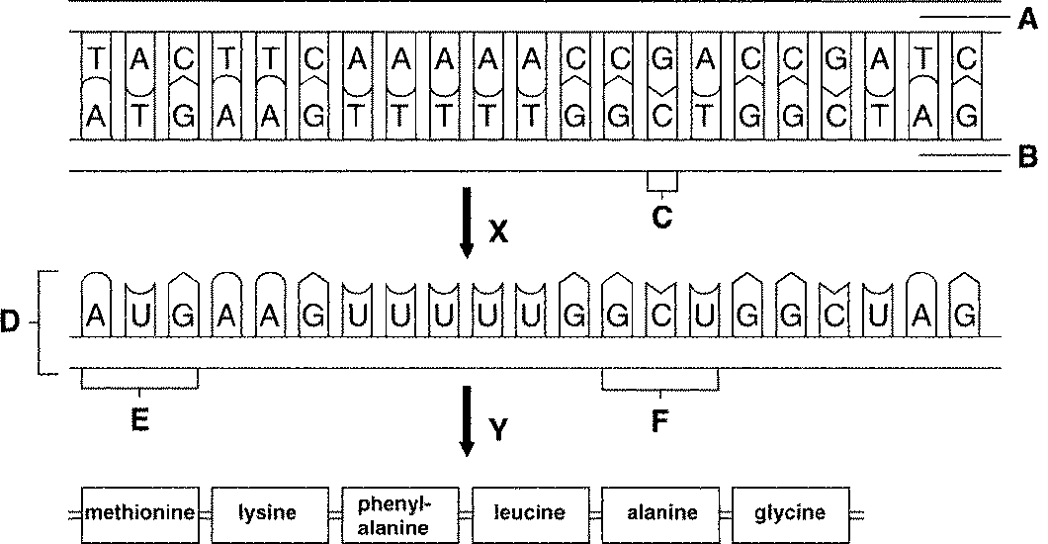
What process is happening at Y?
What process is happening at X?

- A ______________________ is a mistake or change in the DNA sequence.

- A ____________________ mutation is a change to a single base pair that changes an amino acid in a protein.

- A _____________________ mutation is an addition or deletion of one or more bases that changes all the resulting amino acids.

