Academic
2019-2020

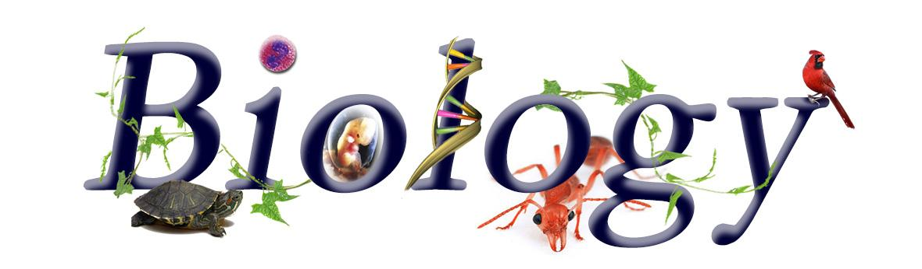

Education is the most powerful weapon which you can use to change the world. ---Nelson Mandela
Instructor: Mrs. Jennifer Tyler
Email: jntyler@wcpss.net
Website: http://jtylerscience.weebly.com
-PowerPoints, Assignments, and Due Dates will be posted on my website. Check it often!

Welcome to Honors Biology at Broughton High! Biology is a science focused on the study of life and living organisms, including their structure, function, growth, evolution, distribution, and taxonomy. In this class we will complete a variety of written assignments, group and individual projects, and hands-on labs to better make sense of the world in which we live. By studying the processes of life, you will be able to make informed decisions about your health and the health of the planet. This course is based on critical thinking, problem solving, experimental design, and effective communication in order to help you become scientifically literate. We will relate current events and environmental issues to the topics covered in the NC Essential Standards for Biology. I’m looking forward to a wonderful year with you and having fun learning science!
Remind App: I will use Remind to send text message reminders of due dates that are approaching in class. This will include upcoming test dates, as well as project and homework due dates. Be sure to sign up for this! Instructions to sign up can be found on my website homepage.
Required Supplies:
Mrs. Tyler’s Wish List:
1. Kleenex
2. Disinfectant wipes
1. 3-ring binder (1.5 inches or larger)
2. Dividers (5)
3. Notebook paper
4. Pencils and Pens (Black or blue only)
5. Recommended: colored pencils and highlighters

Notebooks: You will be doing both written class work and hands-on lab work in biology. You are expected to keep up with all assignments in a binder and to be prepared to show a selection of your work, including class work assignments, bell work, and handwritten class notes. This will mean maintaining good organizational skills. It will be very important to keep up with these materials because the midterm and final exams are cumulative.
Grading Policy: Remember that your grade reflects YOUR effort and the amount of work you put into this class. No one else is responsible for your grade but you! Grades are calculated using a point system. To calculate a percentage grade, divide the points earned by the number of total possible points, then multiply by 100. All assignments will become part of a running point total that will factor into your final grade. The more points you earn, the better your grade will be. You will have the opportunity to do test corrections to earn half credit back for each question missed on a test.
Points Breakdown
Tests : 100 points
Labs: 30 - 60 points
Unit Packets (notes, classwork, bellwork, homework): 80 – 100 points
Other (quizzes, current events, etc.): 10 – 20 points
Final Course Grade
Semester 1 (Q1 and Q2): 40%
Semester 2 (Q3 and Q4): 40%
End of Course Exam: 20%

Curriculum: This course follows the NC Essential Standards for Biology. The link is provided below:

http://www.dpi.state.nc.us/docs/curriculum/science/scos/support-tools/unpacking/science/biology.pdf
Course Outline:
Unit 1: Scientific Method (Experimental Design, Lab Safety, Characteristics of Life)
Unit 2: Biochemistry (pH, Chemistry, Organic Molecules)
Unit 3: Cell Structure and Function (Organelles, Cell Membrane, Active vs. Passive Transport)
Unit 4: Cell Energy (Photosynthesis and Cellular Respiration)
Unit 5: DNA and Protein Synthesis (DNA structure, Transcription/Translation, Mutations)
Unit 6: Cell Division (Mitosis and Meiosis)
Unit 7: Genetics (Punnett Squares, Genetic Disorders, Karyotypes)
Unit 8: Biotechnology (Genetic Engineering, Cloning, Stem Cells)
Unit 9: Evolution (Earth’s History, Darwin and Natural Selection, Speciation)
Unit 10: Classification (Classification System, Kingdoms of Life, Animal/Plant Behavior)
Unit 11: Immunology (Bacteria, Viruses)
Unit 12: Ecology (Energy Flow, Populations, Species Interactions, Environmental Issues, Sustainability)

Homework: Every night students are expected to spend at least 30 minutes reading over lecture notes, learning new terminology, studying diagrams, etc. There is a lot to learn, and you will not be successful if you wait until the last minute to study!
Missed Work: Being in class every day is very important to do well in this class. However, if you miss a day, you are required to make up ALL work you missed (including labs) and cannot use class time to make up work. Any work you miss due to an absence should be completed and turned in within 2 class periods of your absence for full credit. Missed work can be obtained from the “Missed Work” bin, and notes can be obtained from the class website or a classmate. If you miss a test or quiz, it must be made up before or after school within 48 hours of your absence. Ideally you will take the test the next day for unforeseeable, excused absences and the day before for planned absences (like field trips). Depending on the nature of a lab missed, you will either need to schedule an appointment with me to make it up or complete it at home. Any prior work due on the day you are absent will be due the day you return to school.
Late Work: My personal philosophy towards grades is that grades should reflect each students’ mastery of the content material. However, there must be a healthy respect for due dates as there will always be due dates throughout life (mortgages and bills, business proposals, job applications, etc.). Late assignments will be accepted with a deduction of 10 points for each class period the work is late up to a maximum reduction of 40 points. This means that the highest grade a perfect paper that is four days late will receive is a 60. Work turned in after the 1 week mark will not be graded. After one week, we have likely moved on to another topic and the practice has little value.
Tutoring Schedule: I am here to help you and ensure your success! Please seek help early and often if needed. My tutoring days are Tuesdays and Thursdays after school from 2:20-3:30. However, I will be available most other days after school unless I have a meeting. If you cannot make one of those days, let me know at least one day in advance to make an appointment to come before school, stay after school, or during lunch.
Classroom Expectations:
- Be on time to class
- Be prepared with needed materials
- Participate in the assigned activities
- Show respect for others, the classroom, school policies, your learning time, and lab safety guidelines
- Have a positive attitude about learning, and ask questions!

Cell Phone Policy: Extended phone use has been linked to short-term memory loss!
Use of cell phones during instructional time without permission is strictly prohibited. Why? Phones can distract and take away from a student’s learning experience. If you are texting, you are likely missing important material or instructions for activities that you need to be successful in this class. I have seen a direct correlation between cell phone usage and grades over my years of teaching. If a phone is seen by the teacher during class, it will be confiscated for the day. If a phone is seen during an assessment (quiz or test), an automatic zero will be given for the assessment and the phone will be turned in to administration. Electronic devices are not allowed to be charged in the classroom (This is school policy).
PARENTS: If there is an emergency situation when a student needs a phone out in class, please either email me or call the school to let me know. If you need to contact your student during the day, I ask that you do not do so during instructional time or to call the main office if it is an emergency. This is the best way to ensure that you reach your child when they have an opportunity to respond.
Academic Integrity: Any student who engages in or attempts to engage in cheating, plagiarism, or falsification will be subject to disciplinary action and/or academic penalty of a zero grade for the assignment. This includes:
- Copying someone else’s test, quiz, assignment, or report. All work, including homework and lab reports, is expected to be your own.
- Allowing someone to copy your test, quiz, homework, assignment, or report
- Looking at notes or a phone during a test, quiz, or other assessment
- Sharing questions/answers from a test with a student who has not yet taken it
- Using opinions, facts, ideas, charts, data and direct quotes from research papers, websites, etc. without citing the source

I look forward to a great year with you exploring biology! Please feel free to email Mrs. Tyler if you have any questions or concerns. This information is also listed on the class website.

