Heavy Hitters Topic 11.1
- Principles of vaccination
  - vaccine is a modified/weakened/attenuated form of a pathogen / contains antigens from pathogens;
  - vaccine injected/ingested/introduced to patient;
  - pathogen/antigens stimulates specific immune response called primary/initial responses;
  - antigens stimulate macrophages/lymphocytes/T-cells;
  - which stimulate cloning of B-cells/plasma cells;
  - including development of memory (B-)cells;
  - that produce specific antibodies;
  - (upon second exposure) production of antibodies is much faster;
  - higher level of antibody production / person has immunity;
  - called secondary response;
  - labelled graph showing curve with higher slope/peak for secondary response than primary response;
  - may need booster shot to maintain immunity;
  - this is an example of active/artificial immunity;
- Explain immune response
  - a. each antibody corresponds to a specific antigen
  - b. antibodies are necessary for immunity/resistance to «infectious» disease
  - c. macrophage/phagocyte ingests/engulfs pathogen
  - d. macrophage/phagocyte digests pathogen
  - e. macrophage/phagocyte displays antigen from pathogen
  - f. antigens of a pathogen correspond to a specific T lymphocytes/cells
OR
T lymphocytes/cells are activated by antigen binding
  - g. T lymphocytes/cells activate B lymphocytes/cells
  - h. «B cells» divide by mitosis to form many/clones of plasma cells
  - i. plasma cells secrete specific antibody
  - j. some «activated» B lymphocytes/cells act as memory cells
- Process of making monoclonal antibodies
  - B lymphocytes are produced in laboratory animal after injection with an antigen;
  - animal cells/these cells are fused with tumour cells (to form hybridomas which) produce antibodies;
- Active vs passive immunity
  - immunity is the ability of an organism to resist infection;
  - due to presence of (specific) antibodies;
  - immunity can be active or passive;
  - passive due to receiving antibodies from external sources/across placenta/from breast milk/injection;
  - active results from facing an infection directly/through vaccination;
  - pathogen/foreign cell invades body;
  - leads to clonal selection/formation of B memory cells;
  - B-cells produce specific antibodies;
  - if same pathogen enters body again memory cells activated/stimulated to divide;
  - antibodies produced faster and in greater amounts;
- Antibiotics will not work on viruses (only kill biotic (living) things, like bacteria)
- HIV infection – review from SL – look at bioninja

Heavy Hitters Paper 2 Topic 11.2
- Draw and label a diagram of a sarcomere
  - a. actin filaments – drawn as thin lines;
  - b. myosin filaments (with heads) – drawn as thick lines;
  - c. regions of overlap between fibres should follow diagram of sarcomere;
  - d. correct labelling of the A or H band/Z line;
- Explain the process of muscle contraction
  - a. sliding filament model / filaments/actin and myosin slide past each other;
  - b. action potential/depolarisation/nerve impulse arrives at end of motor neurone;
  - c. neurotransmitter/acetylcholine released causing action potential (in muscle fibre);
  - d. sarcoplasmic reticulum releases calcium ions;
  - e. calcium ions cause binding sites on actin/for myosin to be exposed;
  - f. myosin heads bind to sites on actin/form cross-bridges;
  - g. myosin (head) moves actin filament using energy from ATP;
  - h. actin moved towards the centre of sarcomere/M line/M band;
  - i. sarcomeres shortened;
  - j. (binding of) ATP causes release of myosin head from actin;
  - k. conversion of ATP to ADP and Pi causes myosin heads to change angle;
  - l. cycle (of events) repeated (during muscle contraction);
- Explain role of ATP in muscle contraction
  - a. ATP binds to myosin heads;
  - b. ATP used to break cross bridges;
  - c. energy released when ATP forms ADP and phosphate;
  - d. myosin head reset;
  - e. actin slides over myosin;
- Label structures of elbow diagram (muscles, bones, joint, tendon, ligament)

Heavy Hitters Topic 11.3
- Compare blood in the renal artery vs renal vein
  - a. less urea/excretory waste products/creatinine in renal vein
  - b. less oxygen in the renal vein
  - c. more carbon dioxide in renal vein
  - d. less glucose in renal vein
  - e. concentration of sodium ions/chloride ions/pH at normal level in the renal vein whereas it is variable in renal artery
  - f. solute concentration/osmolarity/water balance at normal level in the renal vein whereas it is variable in renal artery
- Explain the process of ultrafiltration
  - blood (in the glomerulus) under high pressure caused by difference in diameter of (afferent and efferent) arterioles;
  - fluid plasma and small molecules forced into kidney tubule/Bowman’s capsule/ through fenestrations/basal membrane;
  - which prevent larger molecules/blood cells from passing through;

- How does the structure of the nephron enable the kidney to function
  - Osmoregulation/excretion of nitrogenous waste/urea «is a function of the» kidney
  - Ultrafiltration in the glomerulus/smaller molecules filtered out in the glomerulus
OR
capillary walls/glomerulus permeable to smaller molecules
Reject ultrafiltration in the Bowman’s capsule.
  - Basement membrane/filtration slits/podocytes act as filter/prevent loss of «large» «proteins»/prevent loss of blood cells
  - High «blood» pressure in glomerulus due to larger afferent than efferent arteriole
  - «Selective» reabsorption of glucose/useful substances in proximal convoluted tubule
  - Microvilli/coiling/convolutions give large surface area
OR
pump proteins to reabsorb specific solutes «in proximal convoluted tubule»
  - Water reabsorbed in descending limb «of loop of Henle»
OR
descending limb permeable to water
  - Active transport/active pumping of sodium ions/Na⁺ out of ascending limb «from filtrate to medulla»
  - Ascending limb is impermeable to water
  - Loop of Henle creates solute gradient/high solute concentration/hypertonic conditions in medulla
  - Distal convoluted tubule adjusts pH/adjusts concentration of Na⁺/K⁺/H⁺
  - Water reabsorbed in collecting duct
  - Collecting duct permeability to water varies due to number of aquaporins/ADH
  - Osmoregulation by varying the amount of water reabsorbed «in the collecting duct»
- Explain the role of the nephron in maintaining water balance in the blood (osmoregulation)
  - water is filtered freely from blood to Bowman’s capsule;
  - majority/80 % of water in filtrate reabsorbed in proximal convoluted tubule;
  - water balance in blood controlled as filtrate passes through collecting duct;
  - descending loop of Henle has water channels/aquaporins/is permeable to water;
  - loop of Henle creates hypertonic conditions in medulla;
  - water moves from tubule to hypertonic more concentrated medulla;
  - ascending loop (of Henle) impermeable to water;
  - Na+/NaCl actively transported out of (thick portion of) ascending limb;
  - anti-diuretic hormone/ADH controls permeability of collecting duct to water;
  - ADH released when blood too concentrated/hypertonic / vice versa;
  - aquaporin channels (in collecting duct) allow water to exit;
  - collecting duct passes through increasing gradient in kidney/medulla;
  - gradient causes reabsorption of more water by osmosis;
  - small volumes excreted if solute concentration too high/blood too concentrated / vice versa;
- Explain the process of ADH secretion and how it is controlled
  - control of ADH secretion by negative feedback;
  - ADH controls water reabsorption in kidney;
  - osmoreceptors in hypothalamus monitor water content (in blood);
  - ADH produced by neurosecretory cells in the hypothalamus;
  - transported (down axons of these cells) to the posterior pituitary;
  - low water content/high solute concentration in blood ((usually) causes action potential to be sent to posterior pituitary);
  - posterior pituitary releases ADH which travels to collecting ducts of kidney;
  - more water reabsorbed (by collecting ducts) making water content (of blood) higher/solute concentration lower;
  - less ADH released;
- Explain how nephron changes the composition of the blood
  - a. higher nitrogen/urea as blood enters nephron/Bowman’s capsule than when it leaves the nephron (in the renal vein);
  - b. most small soluble molecules/glucose/nutrients/ions are removed from blood in Bowman’s capsule;
  - c. through ultrafiltration;
  - d. proteins / blood cells / large molecules remain in the blood;
  - e. as filtrate moves through the nephron (tubule), water is returned to the blood (by osmosis);
  - f. glucose/nutrients is returned to blood by active transport (and diffusion) / selective reabsorption;
  - g. in the proximal convoluted tubule;
  - h. urea / uric acid remain in the filtrate / removed from blood;
  - i. sodium is pumped into the medulla in the loop of Henlé;
  - j. water reabsorption is enhanced by a high sodium gradient (in the medulla);
  - k. permeability of the collecting duct membrane is regulated by hormones / ADH;
  - l. water concentration in urine is variable to maintain homeostasis in the blood;
  - m. more oxygen/less carbon dioxide in blood entering (kidney) than in blood leaving (kidney);
- Outline processes in kidney related to osmoregulation
  - osmoregulation is maintenance of water balance of blood/tissues;
  - loop of Henle creates hypertonic conditions in the medulla;
  - water reabsorbed as filtrate passes through collecting duct;
  - hypothalamus monitors/controls water balance/content of blood;
  - controls secretion of ADH by (posterior) pituitary gland;
  - ADH is released when blood too concentrated/too little water/hypertonic;
  - ADH makes the collecting duct more permeable to water;
  - due to more aquaporins;
  - more water reabsorbed (in response to ADH);
  - less water in urine/urine more concentrated/urine hypertonic;
  - no/less ADH when blood too dilute/too much water/hypotonic;
  - collecting duct less permeable/less water reabsorption/more water in urine;

Heavy Hitters Topic 11.4
- Explain process of spermatogenesis
  - a. germinal cells / spermatogonia undergo mitosis to keep a supply of germinal cells present;
  - b. some germinal cells / spermatogonia grow larger to become primary spermatocytes;
  - c. primary spermatocytes go through meiosis I;
  - d. to form secondary spermatocytes;
  - e. these secondary spermatocytes go through meiosis II;
  - f. to produce spermatids;
  - g. spermatids differentiate/grow a tail and reduce their cytoplasm
  - h. spermatids associated with nurse cells (Sertoli cells);
  - i. sperm detach from Sertoli cells and enter lumen of the seminiferous tubule;
  - j. testosterone stimulates sperm production;

- Compare the process of spermatogenesis and oogenesis
a. both produce haploid cells / both produce (mature/male/female) gametes;
b. both have mitosis at start/in epithelium / both involve mitosis and meiosis;
c. both have cell growth before meiosis;
d. both involve differentiation (to produce a specialised gamete);
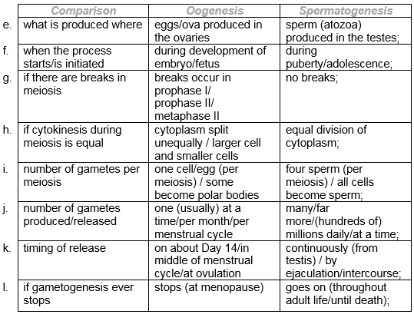
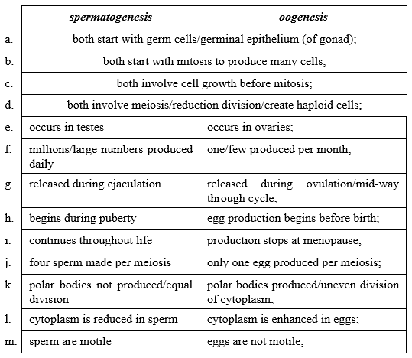
- Explain the structure and function of the placenta
  - disc-shaped structure;
  - connected to the fetus by an umbilical cord;
  - placenta is embryonic and maternal tissue;
  - placental villi increase the surface area (for exchange);
  - fetal capillaries in placenta/placental villi;
  - inter-villous spaces/sinuses through which mother’s blood flows;
  - fetal and mother’s blood do not mix / small distance between fetal and mother’s blood;
  - transfer of foods/nutrients/glucose from mother to fetus;
  - fetal gas exchange/transfer of oxygen from mother to fetus;
  - transfer of excretory/waste products/CO₂ from fetus to mother;
  - transfer of antibodies/hormones from mother to fetus;
  - secretion of estrogen/progesterone/HCG;
- Describe the process of fertilization in humans
  - sperm breaks through follicle cells/cells surrounding the ovum;
  - triggers acrosome reaction;
  - proteases/hydrolytic enzymes (of acrosome) released;
  - digestion of zona pellucida;
  - plasma membranes of sperm and egg fuse;
  - sperm nucleus enters egg;
  - cortical reaction;
  - hardening/cross linking of glycoproteins in zona pellucida;
  - preventing sperm from entering;
- Outline hormonal control of the process of birth
  - level of progesterone decreases (drastically) just before birth;
  - removing inhibition of oxytocin secretion;
  - oxytocin produced by pituitary gland;
  - oxytocin causes contractions of uterus;
  - uterine contractions cause impulses to be sent leading to more oxytocin secretion;
  - positive feedback;
- Annotate drawings of mature egg and sperm, as well as ovaries and testis to show stages of gametogenesis

