Topic 9.4 (AHL) – Plant Reproduction

Understandings, Applications and Skills (This is what you will be assessed on)

 | Statement | Guidance
9.4.U1 | Flowering involves a change in gene expression in the shoot apex.
9.4.U2 | The switch to flowering is a response to the length of light and dark periods in many plants.
9.4.U3 | Success in plant reproduction depends on pollination, fertilization and seed dispersal. | Students should understand the differences between pollination, fertilization and seed dispersal but are not required to know the details of each process
9.4.U4 | Most flowering plants use mutualistic relationships with pollinators in sexual reproduction.
9.4.A1 | Methods used to induce short-day plants to flower out of season. | Flowering in so-called short-day plants such as chrysanthemums, is stimulated by long nights rather than short days.
9.4.S1 | Drawing internal structure of seeds.
9.4.S2 | Drawing of half-views of animal-pollinated flowers.
9.4.S3 | Design of experiments to test hypotheses about factors affecting germination.

Recommended resources:
Mrs. Tyler’s Website
Bioninja
Allott, Andrew. Biology: Course Companion. S.l.: Oxford UP, 2014. Print.

- Define the term angiosperm. What is the reproductive unit of an angiosperm?

- Label and define the function of the following parts of the flower:

a. Petals –

b. Stigma –

c. Style –

d. Ovary –

e. Anther –

f. Filament –

g. Sepals –

h. Peduncle –

i. Ovule -

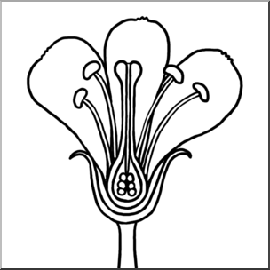

- Which parts of the flower are male? What is this called?

- Which parts of the flower are female? What is this called?
- What are the male and female gametes for plants?

- Describe each of the three steps needed in order for sexual reproduction in plants to occur.
1.

2.

3.

- Why is seed dispersal necessary? List at least four common methods of seed dispersal in plants.

- Define the term monecious.

- Define the term cross-pollination. Why is this advantageous?

- What are some examples of animals that pollinate flowers?

- Describe the mutualistic relationship that exists between pollinators and flowers. Include how flower structure aids this process.

- Explain the relationship between seasons and pollinators in triggering gene expression changes to initiate flowering.

- Control of flowering is governed by photoperiodism. Explain this process and what the critical factor is that plants detect during this process.

- What is a phytochrome?
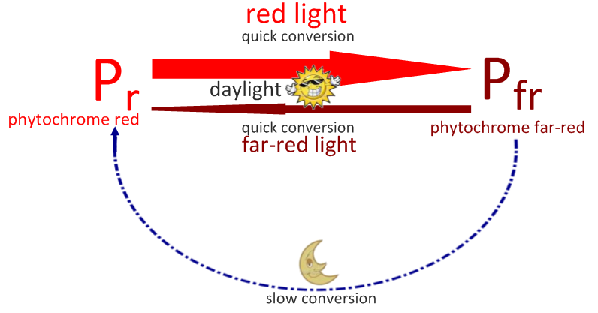
- Fill in the chart and paragraph to explain how phytochromes work.

 | Phytochrome Red (P_{r}) | Phytochrome Far Red (P_{fr})
Active or Inactive
Absorbs what type of light
Most abundant during…

During the daylight, lots of _____________________ light is abundant, so ______________ is converted into _______________. At night, there is neither red nor far red light, so ________________ is slowly converted into ___________________. Plants will detect levels of __________________ to measure the length of _________________________ to determine whether or not it is time to bloom.

- Compare and contrast the flowering of long and short-day plants. Be sure to include the role of P_{fr} in each.

- What is ‘critical night length’?

- When trying to get plants to bloom out of season, why is it best not to interrupt the dark cycle with light?

- List a couple of mechanisms one could use to get each of the following to bloom out of season:

A. Long-day plants

B. Short-day plants

- Label and Define the following parts of the seed:
A. Plumule -

B. Radicle -

C. Cotyledon -

D. Testa -

E. Micropyle –

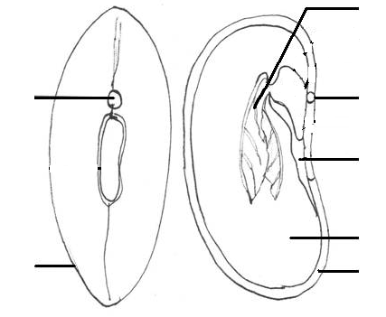
- Define germination.

- What are the basic requirements that all seeds need in order to germinate. Why?

- Explain a few of the more specialized requirements certain seeds may have in addition to the basics to germinate.

- Use a flow chart to describe the steps of germination in starchy seeds.

