Topic 9.3 (AHL) – Plant Growth

Understandings, Applications and Skills (This is what you will be assessed on)

 | Statement | Guidance
9.3.U1 | Undifferentiated cells in the meristems of plants allow indeterminate growth.
9.3.U2 | Mitosis and cell division in the shoot apex provide cells needed for extension of the stem and development of leaves.
9.3.U3 | Plant hormones control growth in the shoot apex. | Auxin is the only named hormone that is expected.
9.3.U4 | Plant shoots respond to the environment by tropisms.
9.3.U5 | Auxin efflux pumps can set up concentration gradients of auxin in plant tissue.
9.3.U6 | Auxin influences cell growth rates by changing the pattern of gene expression.
9.3.A1 | Micropropagation of plants using tissue from the shoot apex, nutrient agar gels and growth hormones.
9.3.A2 | Use of micropropagation for rapid bulking up of new varieties, production of virus-free strains of existing varieties and propagation of orchids and other rare species.

Recommended resources:
Mrs. Tyler’s Website
Bioninja
Allott, Andrew. Biology: Course Companion. S.l.: Oxford UP, 2014. Print.

- Define meristem.

- Outline the function of the two major types of meristems:

a. apical meristems –

b. lateral meristems –

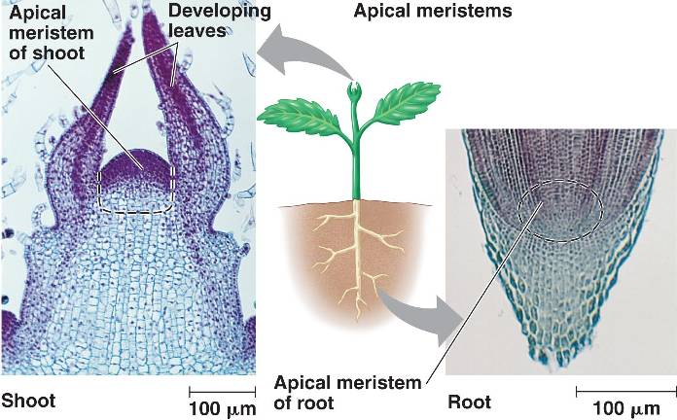
- Outline the difference between primary and secondary growth.

- What two processes lead to growth in a multicellular organism?

- Outline the difference between an axillary bud, node, and the apical meristem.

- What hormone is primarily responsible for plant growth, and where is it produced in the plant?

- Describe the concept of apical dominance.

- Outline how the concentration of auxin affects plant growth. How does auxin travel between cells?

- Outline how auxin affects gene patterns in both shoots and roots in plants.

- Explain the mechanism of H+ ions in gene expression changes due to auxin efflux in a cell.

- Define tropism. What is the difference between positive and negative tropisms?

- What is each of the following tropisms in response to?

a. phototropism –

b. gravitropism –

c. thigmotropism –

- Outline how auxin concentrations influence phototropisms.

- Outline how auxin concentrations influence gravitropisms.

- What is micropropogation, and what makes this process feasible?

- Briefly outline the process of micropropogation.

- Explain three uses of micropropogation.

