Topic 9.2 (AHL) – Phloem Transport

Understandings, Applications and Skills (This is what you will be assessed on)

 | Statement | Guidance
9.2.U1 | Plants transport organic compounds from sources to sinks.
9.2.U2 | Incompressibility of water allows transport along hydrostatic pressure gradients.
9.2.U3 | Active transport is used to load organic compounds into phloem sieve tubes at the source.
9.2.U4 | High concentrations of solutes in the phloem at the source lead to water uptake by osmosis.
9.2.U5 | Raised hydrostatic pressure causes the contents of the phloem to flow towards sinks.
9.2.A1 | Structure–function relationships of phloem sieve tubes.
9.2.S1 | Identification of xylem and phloem in microscope images of stem and root.
9.2.S2 | Analysis of data from experiments measuring phloem transport rates using aphid stylets and radioactively-labelled carbon dioxide.

Recommended resources:
Mrs. Tyler’s Website
Bioninja
Allott, Andrew. Biology: Course Companion. S.l.: Oxford UP, 2014. Print.

- State the function of phloem.

- Distinguish between source and sink in terms of molecules in plants.

- The phloem is made up primarily of sieve elements and companion cells.

  - Explain the structure and function of sieve element cells.

  - Explain the structure and function of companion cells.

- Label and Annotate the diagram below to explain how the structure of the phloem is related to its function.

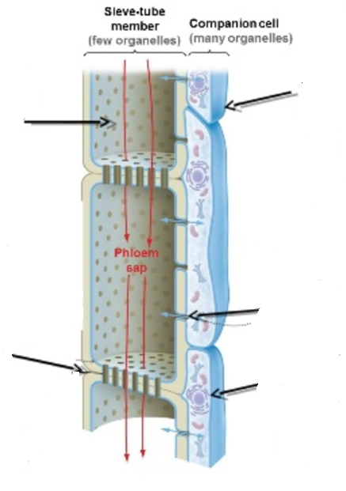

- Define active translocation.

- Complete the table below to show the sources and sinks of sugars and amino acids carried in plant sap.
 | Sugars | Amino Acids
Sources
Sinks

- Explain (in detail) how each of the following two things help sucrose move through the plant from source to sink.

  - Active Transport

  - Hydrostatic Pressure

- Outline how sucrose is loaded at the source. [Use the terms osmosis and water potential/hydrostatic pressure in your answer].

- Outline how sucrose is unloaded at the sink. [Use the terms osmosis and water potential/hydrostatic pressure in your answer].

- Draw and annotate a picture that shows the process of translocation. (Include sink/root, sieve plate, companion cells, source/leaf, phloem, xylem.

- Summarize the 7 steps of translocation theory.

- Outline how aphids are used to measure sap flow rate.

