Topic 9.1 (AHL) – Xylem Transport

Understandings, Applications and Skills (This is what you will be assessed on)

 | Statement | Guidance
9.1.U1 | Transpiration is the inevitable consequence of gas exchange in the leaf.
9.1.U2 | Plants transport water from the roots to the leaves to replace losses from transpiration.
9.1.U3 | The cohesive property of water and the structure of the xylem vessels allow transport under tension.
9.1.U4 | The adhesive property of water and evaporation generate tension forces in leaf cell walls.
9.1.U5 | Active uptake of mineral ions in the roots causes absorption of water by osmosis.
9.1.A1 | Adaptations of plants in deserts and in saline soils for water conservation.
9.1.A2 | Models of water transport in xylem using simple apparatus including blotting or filter paper, porous pots and capillary tubing.
9.1.S1 | Drawing the structure of primary xylem vessels in sections of stems based on microscope images.
9.1.S2 | Measurement of transpiration rates using potometers. (Practical 7)
9.1.S3 | Design of an experiment to test hypotheses about the effect of temperature or humidity on transpiration rates.

Recommended resources:
Mrs. Tyler’s Website
Bioninja
Allott, Andrew. Biology: Course Companion. S.l.: Oxford UP, 2014. Print.

- Define transpiration.

- Explain how the action of guard cells allows the plant to balance CO₂ uptake with control over water loss. What environmental conditions will cause them to open/close?

- Outline how turgor pressure plays a role in whether or not a stoma is open or shut.

- What does the hormone abscisic acid do?

- Complete the table to explain how the following abiotic factors affect the rate of transpiration:

 | Effect | Reason
Temperature
Light
Wind
Humidity

- Which part of the vascular tissue transports water from the roots to the leaves?

- Define transpiration stream.

- Outline the two properties of water that allow the transpiration stream (“pull”) to be generated.

- Explain the role of tension in the leaf in making transpiration and water transport up the stem possible.

- Annotate the diagram to explain how the structure of primary xylem facilitates transpiration.

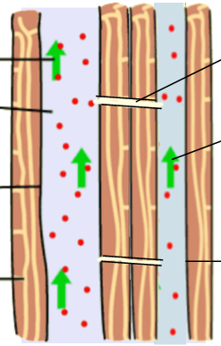

- Describe how lignified xylem helps support a plant.

- Compare and contrast active and passive transport.

- Outline the process of osmosis. Does this require energy? How does solute concentration affect the direction of water flow?

- What is the advantage that a plant gains by having a highly branched structure and/or roots hairs?

- Explain why mineral ions need to be taken up by active transport in the roots. Why is this necessary for the uptake of water?

- Summarize how water leaves the leaves (the process of transpiration).

- What is a xerophyte and how is it adapted for dry conditions?

- Describe how CAM plant metabolism is an adaptation to preventing water loss.

- What is a halophyte and how is it adapted for salty conditions?

