Topic 7 Nucleic Acids (AHL) – 7.3 Translation

Understandings, Applications and Skills (This is what you will be assessed on)

 | Statement | Guidance
7.3.U1 | Initiation of translation involves assembly of the components that carry out the process. | Examples of start codons are not required. Names of the tRNA binding sites are expected as well as their roles.
7.3.U2 | Synthesis of the polypeptide involves a repeated cycle of events.
7.3.U3 | Disassembly of the components follows termination of translation. | Examples of stop codons are not required.
7.3.U4 | Free ribosomes synthesize proteins for use primarily within the cell.
7.3.U5 | Bound ribosomes synthesize proteins primarily for secretion or for use in lysosomes.
7.3.U6 | Translation can occur immediately after transcription in prokaryotes due to the absence of a nuclear membrane.
7.3.U7 | The sequence and number of amino acids in the polypeptide is the primary structure.
7.3.U8 | The secondary structure is the formation of alpha helices and beta pleated sheets stabilized by hydrogen bonding.
7.3.U9 | The tertiary structure is the further folding of the polypeptide stabilized by interactions between R groups. | Polar and non-polar amino acids are relevant to the bonds formed between R groups.
7.3.U10 | The quaternary structure exists in proteins with more than one polypeptide chain. | Quaternary structure may involve the binding of a prosthetic group to form a conjugated protein.
7.3.A1 | tRNA-activating enzymes illustrate enzyme–substrate specificity and the role of phosphorylation.
7.3.S1 | Identification of polysomes in electron micrographs of prokaryotes and eukaryotes.
7.3.S2 | The use of molecular visualization software to analyse the structure of eukaryotic ribosomes and a tRNA molecule.

Recommended resources:
Allott, Andrew. Biology: Course Companion. S.l.: Oxford UP, 2014. Print.
Mrs. Tyler’s Flipped Lessons

Flip Video: Ribosomes and tRNA

7.3.S2 The use of molecular visualization software to analyse the structure of eukaryotic ribosomes and a tRNA molecule.

- State the molecules a ribosome is made of.

- Draw a diagram to outline the structure of a ribosome. Label the following:
  - large subunit
  - small subunit
  - three tRNA binding sites E,P,A (located on the large subunit)
  - mRNA and the mRNA binding site (located on the small subunit)
  - A growing polypeptide chain

- Outline the function of each of the three tRNA binding sites on the ribosome:

A. aminoacyl (A) site

B. Peptidyl (P) site

C. Exit (E) site

- State the difference between prokaryotic and eukaryotic ribosomes.

- Label the following regions on the cloverleaf model of a tRNA molecule, outlining the function of each.

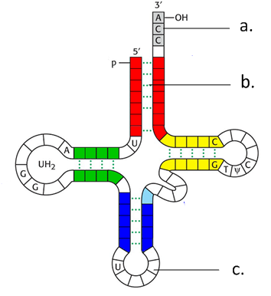 | a.
 |  | function:
 | b. | Hydrogen Bonds
 |  | function:
 | c.
 |  | function:

- Use the RCSB Protein Bank and Chemapps to explore the following Jmol images:

  - The whole ribosome: https://chemapps.stolaf.edu/jmol/jmol.php?source=https://bioninja.com.au/_Media/ribosome.pdb&width=100%&height=100%

  - The small ribosomal subunit http://www.rcsb.org/pdb/explore/jmol.do?structureId=1GIY&bionumber=1

  - The large ribosomal subunit http://www.rcsb.org/pdb/explore/jmol.do?structureId=1JGO&bionumber=1

  - A tRNA molecule
https://chemapps.stolaf.edu/jmol/jmol.php?source=https://bioninja.com.au/_Media/tRNA.pdb&width=100%&height=100%

7.3.A1 tRNA-activating enzymes illustrate enzyme–substrate specificity and the role of phosphorylation.

- State how many tRNA activating enzymes there are. Explain why this is.

a. Explain how this also relates to enzyme-substrate specificity.
- Referring to the diagram below outline how tRNA is activated.
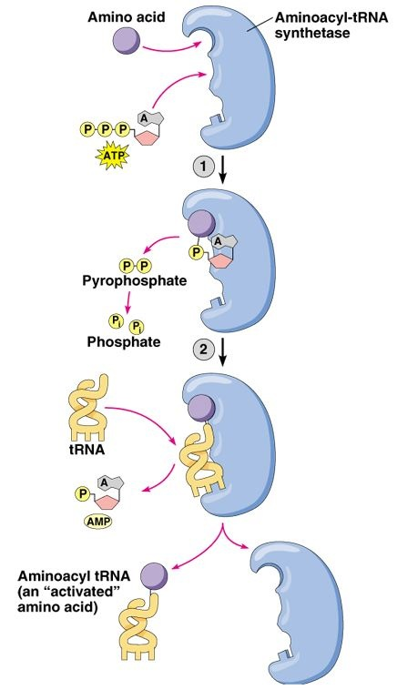
- State what the energy that is transferred from ATO to the ‘charged’ tRNA molecule is used for.

Flip Video: Translation

7.3 U1 Initiation of translation involves assembly of the components that carry out the process.
7.3.U2 Synthesis of the polypeptide involves a repeated cycle of events.
7.3.U3 Disassembly of the components follows termination of translation.

- Define translation.

- State what is meant by the term degeneracy as it relates to the reading of codons.

- State what the first amino acid of every protein chain will be. Why?

- Complete the table to summarize the process of translation.
Stage | Key steps
Initiation | Assemble the three components that carry out the process (mRNA, tRNA, ribosome)  - _______________ ribosomal subunit binds to 5’ end of ____________ and moves along it until it reaches the ____________________________ (_____________)  - ____________ molecule carrying _______________________ binds to the start codon via its _______________________________ (according to complementary base pairing)  - The _______________ ribosomal ____________________ _______________ to the small subunit  - aligns itself to the _______________ molecule at the __________ site
Elongation | Addition of New Amino Acids  - A second tRNA molecule pairs with the next codon in the ______ ______________  - A covalent __________________ _______________ is formed between the amino acids in the ___________ and __________ sites  -tRNA in the _______ site is now holding the peptide chain  (Charged tRNA contains energy in the bond with the amino acid attached which will be used to form the peptide bond.)  Translocation  - _____________________ moves ____________________ one codon position (_____ to ______ direction)  - Deacylated tRNA (no aa) in P site moves to E site and is released  - tRNA in A site carrying peptide chain moves to P site  - Another tRNA molecule attaches in now vacant A site, and the process continues
Termination | Disassemble ribosomal components  - Elongation continues until the ribosome reaches a _____________ codon  - Stop codons don’t recruit a tRNA molecule, but instead ____________________________  ________________________________________________________________________  ________________________________________________________________________  - The ___________________________ is __________________________ and the ______________________ _____________________________ back into its two independent subunits.

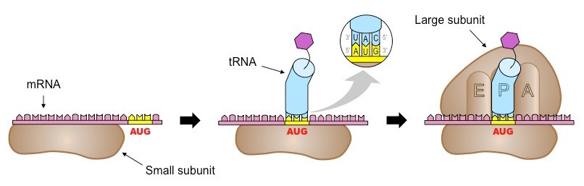
Initiation

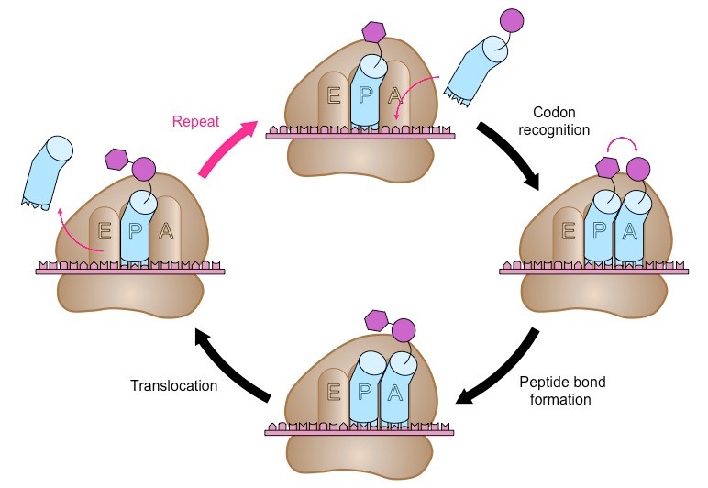
Elongation

Termination
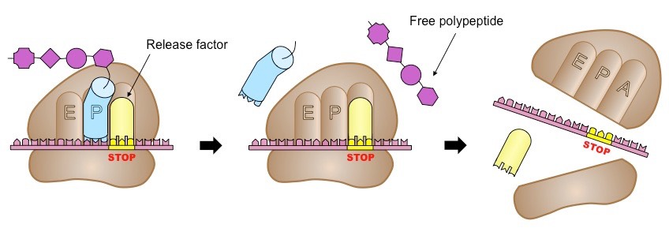

Translation Videos/Animations to watch:
- http://highered.mheducation.com/sites/0072507470/student_view0/chapter3/animation__protein_synthesis__quiz_3_.html
- http://www.hhmi.org/biointeractive/translation-advanced-detail
- https://www.dnalc.org/resources/3d/13-transcription-advanced.html
- https://www.youtube.com/watch?v=KZBljAM6B1s&feature=youtu.be
7.3.U6 Translation can occur immediately after transcription in prokaryotes due to the absence of a nuclear membrane.

- State two reason why translation can occur immediately after transcription in prokaryotes.

7.3.S1 Identification of polysomes in electron micrographs of prokaryotes and eukaryotes.

  - Define polysome.

  - Label the eukaryotic (left) and prokaryotic (right) polysomes, indicating:
    - mRNA
    - Ribosomes
    - Polypeptide chains

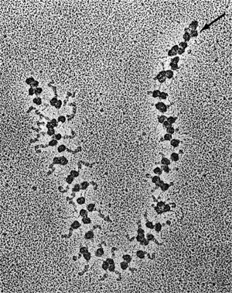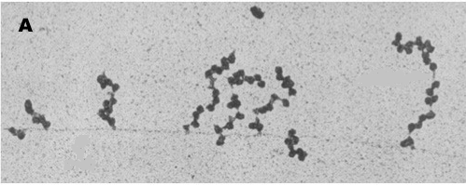

  - Describe how polysomes in prokaryotes may differ in structure from polysomes in eukaryotes.

Flip Video: Protein Structure and Destination

7.3.U7 The sequence and number of amino acids in the polypeptide is the primary structure.
7.3.U8 The secondary structure is the formation of alpha helices and beta pleated sheets stabilized by hydrogen bonding.
7.3.U9 The tertiary structure is the further folding of the polypeptide stabilized by interactions between R groups.
7.3.U10 The quaternary structure exists in proteins with more than one polypeptide chain.

- List some of the important functions of proteins within the cell.

- State the types of proteins produced by:

A. Free ribosomes:

B. Attached ribosomes (rough ER):

- State what determines whether or not a ribosome will become attached to the rough ER or not.

- Once a polypeptide is made, it must be folded properly into a 3D conformation in order to perform its function. The structure is the result of the polar nature of water in the cytoplasm, hydrogen bonds and interactions between the R-groups. Label the level of organization on the diagram below.

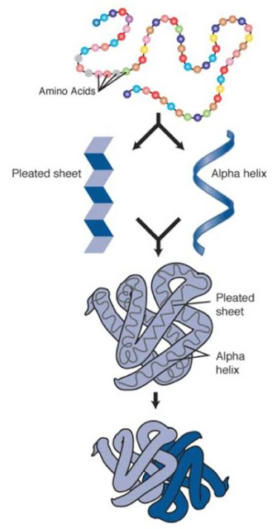
Complete the table to outline the four different levels of protein structure. Include the definition, what types of bonds are involved.

Notes
Primary (polypeptide)
Secondary
Tertiary
Quaternary
- Explain the 4 types of interactions involved in the formation of the tertiary structure.

- Compare and contrast fibrous and globular proteins.

Nature of Science: Developments in scientific research follow improvements in computing—the use of computers has enabled scientists to make advances in bioinformatics applications such as locating genes within genomes and identifying conserved sequences. (3.7)

- Without computers analysis of the molecular structure such as ribosomal and tRNA structure would not be possible. Bioinformatics also relies on computers to large extent.
  - Outline the field of bioinformatics and what it involves.

  - Explain why computers are a necessity for scientists working in this field.

