Topic 7 Nucleic Acids (AHL) – 7.2 Transcription

Understandings, Applications and Skills (This is what you will be assessed on)

 | Statement | Guidance
7.2.U1 | Transcription occurs in a 5’ to 3’ direction. | RNA polymerase adds the 5´ end of the free RNA nucleotide to the 3´ end of the growing mRNA molecule.
7.2.U2 | Nucleosomes help to regulate transcription in eukaryotes.
7.2.U3 | Eukaryotic cells modify mRNA after transcription.
7.2.U4 | Splicing of mRNA increases the number of different proteins an organism can produce.
7.2.U5 | Gene expression is regulated by proteins that bind to specific base sequences in DNA.
7.2.U6 | The environment of a cell and of an organism has an impact on gene expression.
7.2.A1 | The promoter as an example of non-coding DNA with a function.
7.2.S1 | Analysis of changes in the DNA methylation patterns.

Recommended resources:
Allott, Andrew. Biology: Course Companion. S.l.: Oxford UP, 2014. Print.

Mrs. Tyler’s Flipped Lessons:
Flip Video: Transcription

Background
- Define a gene.

- Outline the two steps needed to make a protein.

- Compare and contrast DNA and RNA.

7.2.U1 Transcription occurs in a 5’ to 3’ direction.

- State the direction of transcription and draw a simple diagram to show the addition of an RNA molecule to a growing mRNA strand.

- State the role of NTPs in mRNA production.

- Label the sense and antisense strand, then define them.

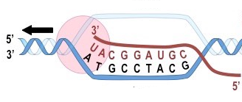

- Annotate the diagram to explain the role of each of the three parts of a gene.
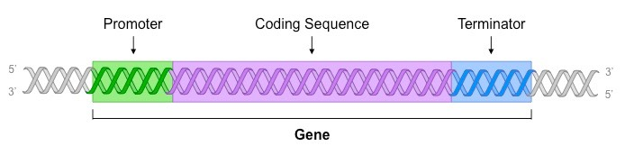

- Outline the three steps of transcription.

9. Define the term operon.

Transcription videos/animations to watch:
- http://highered.mcgraw-hill.com/sites/0072507470/student_view0/chapter3/animation__mrna_synthesis__transcription___quiz_1_.html
- https://www.youtube.com/watch?v=5MfSYnItYvg
- http://www.stolaf.edu/people/giannini/flashanimat/molgenetics/transcription.swf (use internet explorer)

Flip Video: mRNA Processing

7.2.U3 Eukaryotic cells modify mRNA after transcription.

- State the only type of cells that require mRNA processing to form mature mRNA. Why?

- List the 3 steps involved in mRNA processing.

- Outline the process of capping and explain why it is important in mRNA processing.

- Outline the process of polyadenylation and explain why it is important in mRNA processing.

- Distinguish between introns and exons in eukaryotic DNA.

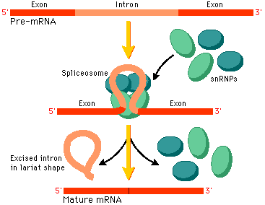
- Define splicing.

- Complete the table to outline the process of splicing in mature mRNA formation.

Spliceosome | - causes the intron to form a loop
Introns
Mature mRNA | - contains only exons
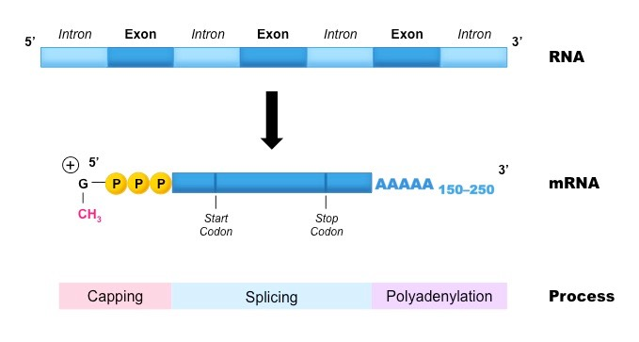
Mature mRNA
7.2.U4 Splicing of mRNA increases the number of different proteins an organism can produce.

- The splicing process above can happen in different ways to the same gene, and can involve removal of exons. This is called alternative splicing.
  - Describe how this happens.

  - What are the implications for the proteins made by genes that are alternatively spliced?

  - Name two examples of a protein families that are commonly alternatively spliced.

