Topic 7 Nucleic Acids (AHL) – 7.2 Gene Expression

Understandings, Applications and Skills (This is what you will be assessed on)

 | Statement | Guidance
7.2.U1 | Transcription occurs in a 5’ to 3’ direction. | RNA polymerase adds the 5´ end of the free RNA nucleotide to the 3´ end of the growing mRNA molecule.
7.2.U2 | Nucleosomes help to regulate transcription in eukaryotes.
7.2.U3 | Eukaryotic cells modify mRNA after transcription.
7.2.U4 | Splicing of mRNA increases the number of different proteins an organism can produce.
7.2.U5 | Gene expression is regulated by proteins that bind to specific base sequences in DNA.
7.2.U6 | The environment of a cell and of an organism has an impact on gene expression.
7.2.A1 | The promoter as an example of non-coding DNA with a function.
7.2.S1 | Analysis of changes in the DNA methylation patterns.

Recommended resources:
Allott, Andrew. Biology: Course Companion. S.l.: Oxford UP, 2014. Print.

Mrs. Tyler’s Flipped Lessons:
Flip Video: Gene Expression

Background:
1. State what it means when a gene is expressed.

2. Every single cell in an organism’s body has the exact same copy of DNA. Explain why gene expression is regulated so that some genes are expressed in all cells all of the time versus only in certain cells or at certain times.

3. List the 3 main levels at which gene expression can be controlled in eukaryotes

7.2.A1 The promoter as an example of non-coding DNA with a function.

- Coding regions are used as a guide for the production of polypeptides, but non-coding regions are not. Non-coding regions do however have important functions, for example promoters. Outline how promoter regions of DNA regulate protein production (gene expression) by controlling the initiation of transcription.

7.2.U5 Gene expression is regulated by proteins that bind to specific base sequences in DNA.

- Complete the table to outline the functions proteins on gene expression regulation in eukaryotes.
Control Element | Binding protein | Function | Distance from gene

- One well known example of the regulation of gene expression by proteins is the metabolism of lactose in E. coli (prokaryotic bacteria). The diagram below illustrates this example. Complete the statements.

 | 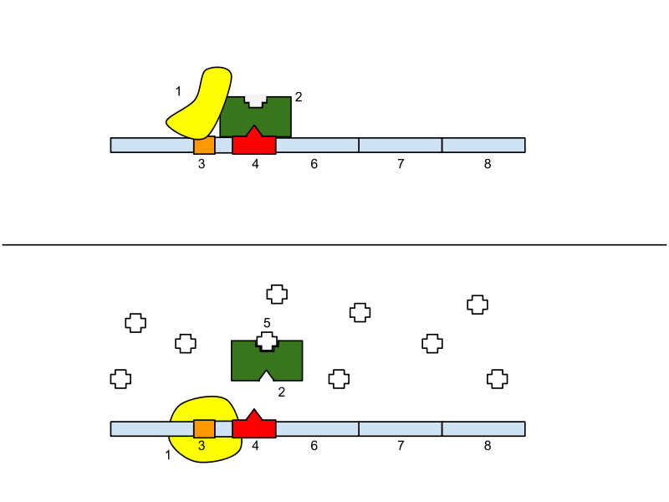 |  |  |  | _____________ binds to the operator. _____________ cannot bind to the ___________ therefore the genes that produce proteins involved in lactose metabolism ___________ be transcribed.
 |  |  |  |  | _____________ binds to the repressor. The _____________ cannot bind to the operator. RNA polymerase binds to the _____________ allowing the genes that produce proteins involved in lactose metabolism ___________ be transcribed.
Key
1 |  | RNA Polymerase | 4 | Operator
2 |  | Repressor | 5 | Lactose
3 |  | Promoter | 6, 7 & 8 | Genes that produce proteins (e.g. enzymes involved in lactose metabolism)
4. Outline how the structure of chromatin impacts whether or not a gene can be transcribed.

5. Label the diagram stating if the gene is active or inactive.

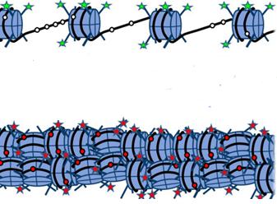

Animation on activators and repressors:
http://www.hhmi.org/biointeractive/regulation-eukaryotic-dna-transcription

6. Gene regulation in eukaryotes is more complex than in prokaryotes (who typically are only regulated at the level if initiating transcription). List the ways in which this occurs in eukaryotes.

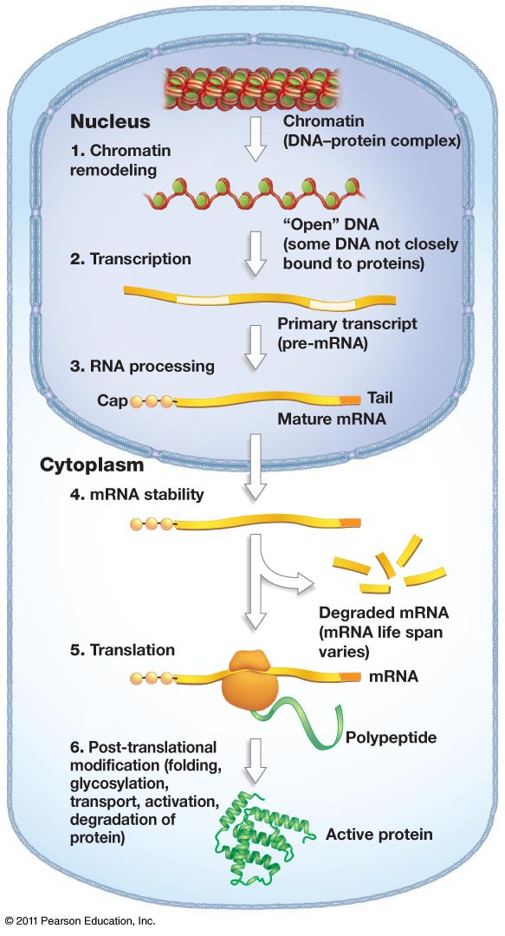
Initiation of transcription

RNA Processing

Translation

Protein Activity

Flip Video: Environmental Influences on Genes

7.2.U6 The environment of a cell and of an organism has an impact on gene expression.

1. Environmental stimuli can generate chemical signals within the cell that can change levels of regulatory proteins or transcription factors. Summarize at least four examples of this.

Flip Video: Epigenetics

7.2.U2 Nucleosomes help to regulate transcription in eukaryotes.

- Compare and contrast genetics and epigenetics.

- Define the terms euchromatin and heterochromatin.

- Review your understanding of nucleosomes. Identify which region of histone molecules are exposed and hence may easily be modified to affect transcription regulation. (hint: annotate the diagram).

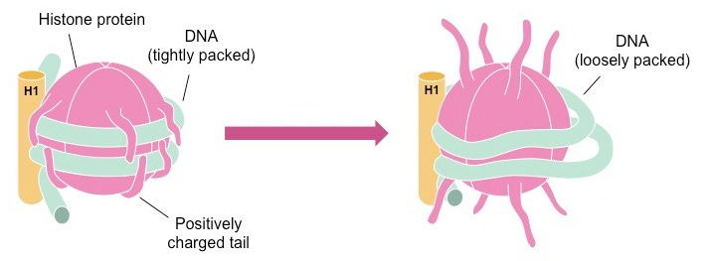
- State the names of the two key chemical groups that can be added to histones and outline how the modification of histones can activate or deactivate genes.
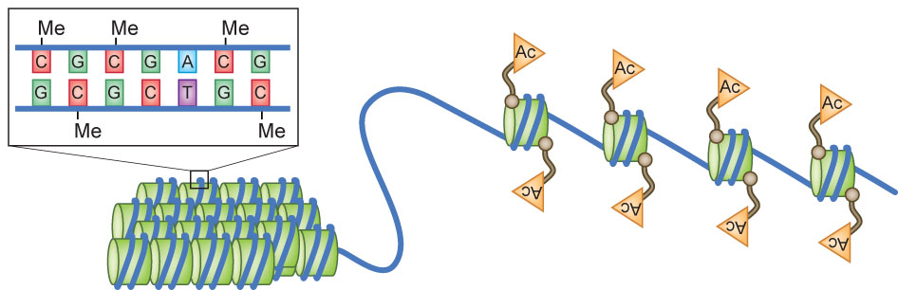

- Define DNA methylation and its role in gene regulation.

- State the name of the branch of genetics concerned with heritable change in gene function that occurs without a change to the DNA sequence.

Nature of Science: Looking for patterns, trends and discrepancies - there is mounting evidence that the environment can trigger heritable changes in epigenetic factors. (3.1)

- Outline how epigenetic modifications (ex: methylation patterns) may be influenced by environmental factors.

- Outline how methylation patterns are different between specialized cell types.

- Explain how your parent’s lifestyle choices can influence your gene expression. How do you inherit epigenetic tags from your parents?

(We will use the Learn Genetics resources (http://learn.genetics.utah.edu/content/epigenetics/) to identify and outline the evidence that supports the idea that the environment can trigger heritable changes in epigenetic factors in class.)

