Topic 11.4 (AHL) – Sexual Reproduction

Understandings, Applications and Skills (This is what you will be assessed on)

 | Statement
11.4.U1 | Spermatogenesis and oogenesis both involve mitosis, cell growth, two divisions of meiosis and differentiation.
11.4.U2 | Processes in spermatogenesis and oogenesis result in different numbers of gametes with different amounts of cytoplasm.
11.4.U3 | Fertilization in animals can be internal or external.
11.4.U4 | Fertilization involves mechanisms that prevent polyspermy. [Fertilization involves the acrosome reaction, fusion of the plasma membrane of the egg and sperm and the cortical reaction.]
11.4.U5 | Implantation of the blastocyst in the endometrium is essential for the continuation of pregnancy.
11.4.U6 | HCG stimulates the ovary to secrete progesterone during early pregnancy.
11.4.U7 | The placenta facilitates the exchange of materials between the mother and fetus.
11.4.U8 | Estrogen and progesterone are secreted by the placenta once it has formed.
11.4.U9 | Birth is mediated by positive feedback involving estrogen and oxytocin.
11.4.A1 | The average 38-week pregnancy in humans can be positioned on a graph showing the correlation between animal size and the development of the young at birth for other mammals.
11.4.S1 | Annotation of diagrams of seminiferous tubule and ovary to show the stages of gametogenesis.
11.4.S2 | Annotation of diagrams of mature sperm and egg to indicate functions.

Recommended resources:
Mrs. Tyler’s Website
Bioninja
Allott, Andrew. Biology: Course Companion. S.l.: Oxford UP, 2014. Print.

GO BACK AND LOOK AT CELL DIVISION POWERPOINTS (FOCUSING ON MEIOSIS) IN TOPIC 10 ON MY WEBSITE FOR A REVIEW OF MITOSIS AND MEIOSIS

- Define the following terms:

  - Somatic cell –

  - Gametes –

  - Diploid (2n) –

  - Haploid (n) –

  - Zygote –

- What cells are diploid? What is the diploid number for humans?

- What cells are haploid? Why are these cells haploid?

11.4.S2 Annotations of diagrams of mature sperm and egg to indicate functions.

- Label AND annotate the diagram of a mature human egg to outline the functions of each structure:

  - (Haploid) Nucleus

  - Zona Pellucida

  - Follicle Cells (Corona Radiata)

  - Cortical Granules

  - Cytoplasm
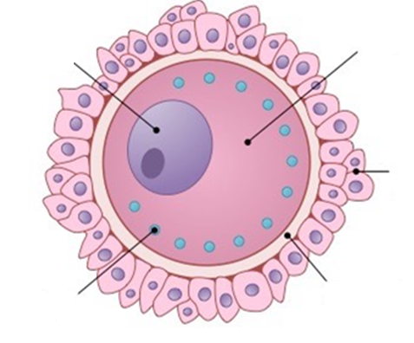

- Label AND annotate the diagram of a mature human sperm to outline the functions of each structure:
  - Head

  - Acrosome

  - Nucleus

  - Midpiece

  - Flagella (Tail)

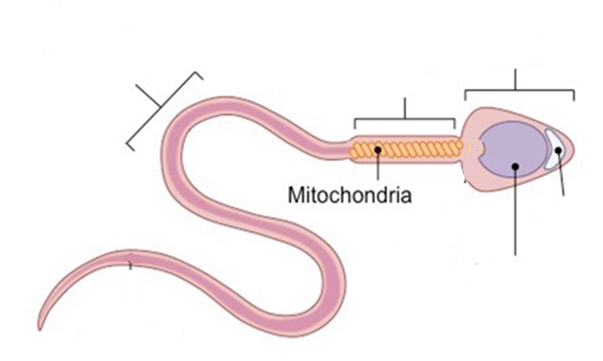

11.4.S1 Annotation of a diagram of seminiferous tubule and ovary to show the stages of gametogenesis.

- Where are gametes produced in males?

- Outline the process that happens in the seminiferous tubule to create sperm (in terms of cell divisions and differentiation).

- Outline the role of the following in spermatogenesis:
  - Basement membrane

  - Sertoli cells

  - Interstitial cells (Leydig cells)

- Label the diagram of a seminiferous tubule below to show the stages of gametogenesis:
  - Interstitial cells, basement membrane, spermatogonium, primary spermatocyte, secondary spermatocyte, spermatids, developing spermatozoa, Sertoli cells, lumen of the tubule.

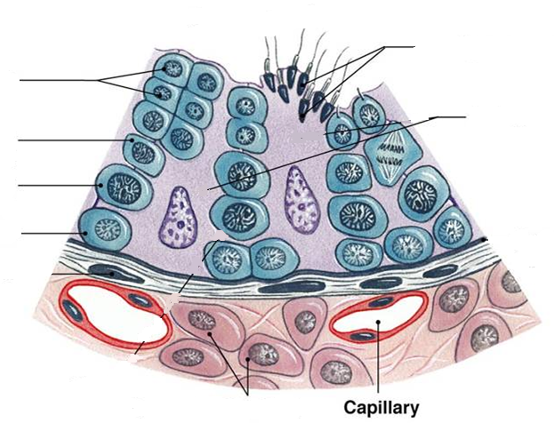

11.4.U1 Spermatogenesis and oogenesis both involve mitosis, cell growth, two divisions of meiosis and differentiation.

- Define gametogenesis. What is this process called in males? Females?

- What are the three major steps involved in gametogenesis?

- Outline the process of spermatogenesis within the testes, including mitosis, the two phases of meiosis and cell differentiation.
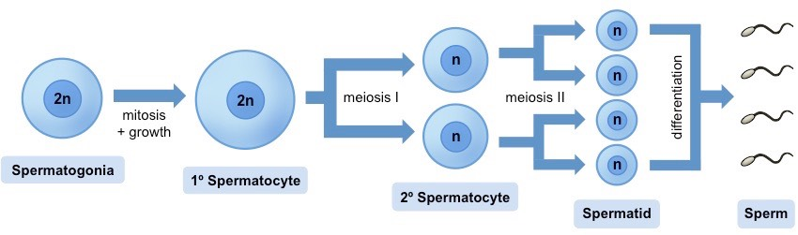

- Label the following in the cross section of the testes below: Leydig cells (interstitial cells), spermatogonia, spermatozoa, lumen.

- Where are gametes formed in females? When does oogenesis start? Stop?

- Outline the process of oogenesis within the ovary, including mitosis, the two phases of meiosis, the unequal divisions of the cytoplasm and the degeneration of the polar bodies.
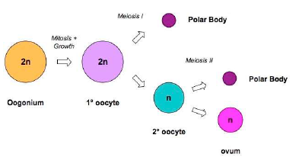

- Label the polar body in the picture below that is created by unequal division of the cytoplasm during meiosis in oogenesis.
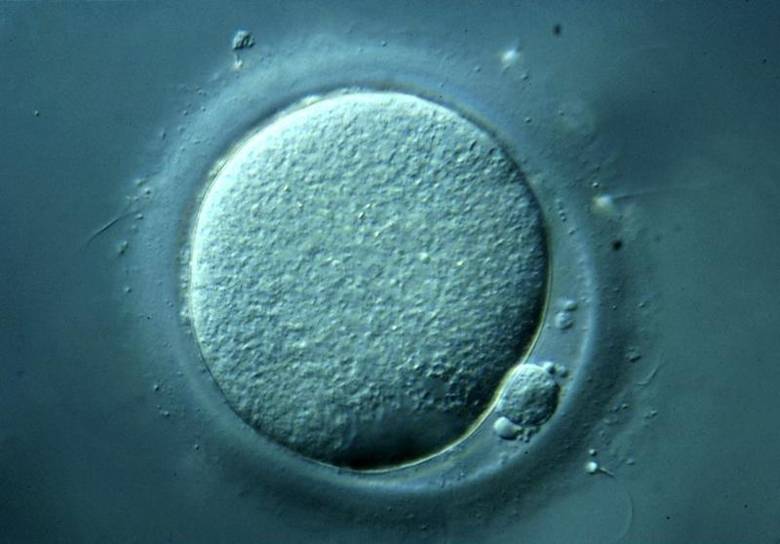

11.4.S1 Annotation of a diagram of seminiferous tubule and ovary to show the stages of gametogenesis.

- The ovary contains follicles at various stages of development (follows the stages of oogenesis).
  - Why won’t all follicles be apparent when you examine an ovary?

  - Explain the progression of follicles as it relates to the course of the menstrual cycle and oogenesis.

- Label on a diagram of an ovary: primordial follicles, primary follicles, primary oocytes, developing follicles, secondary oocycte, mature (Graafian) follicle, corpus luteum, mature egg, degenerating corpus luteum, and corpus albicans.

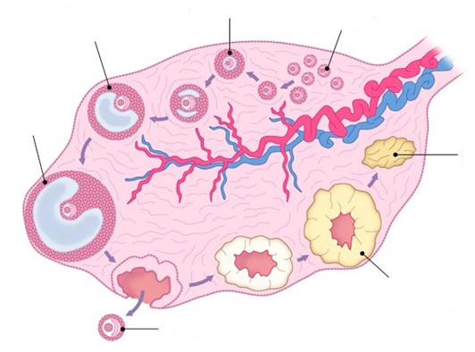
- Label on the cross section of the ovary: germline epithelium, primary follicles, mature follicle, secondary oocyte.
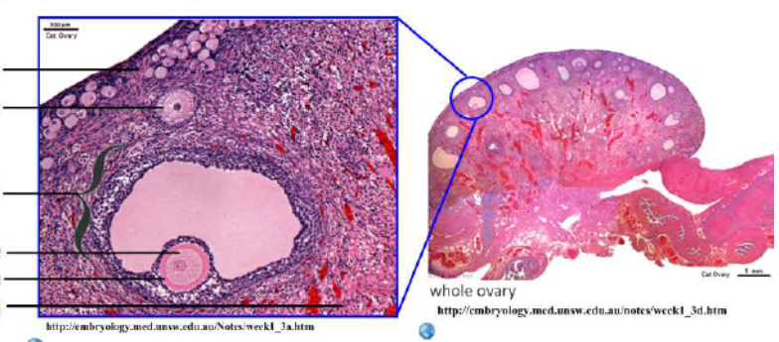
11.4.U2 Processes in spermatogenesis and oogenesis result in different numbers of gametes with different amounts of cytoplasm.

- Compare and contrast the processes of spermatogenesis and oogenesis, including the process, resulting daughter cells, timing, location, etc. (Hint: Create a chart to compare and contrast the similarities and differences).

11.4.U3 Fertilization in animals can be internal or external.

- Compare and contrast the processes of internal and external fertilization, giving an example of each.

- Explain the steps involved in the process of fertilization to form a zygote. Be detailed!
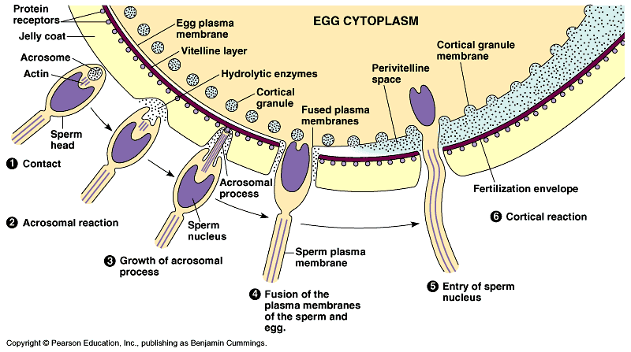

11.4.U4 Fertilization involves mechanisms that prevent polyspermy

- Define polyspermy.

- What process during fertilization in mammals is responsible for preventing polyspermy? Suggest why most mammals have mechanisms to prevent polyspermy.

- What prompts the egg to finish meiosis II during fertilization?

11.4.U5 Implantation of the blastocysts in the endometrium is essential for the continuation of pregnancy.

- Outline the process of development from a zygote to a blastocyst.

- Draw and label a diagram of a blastocyst, including the inner cell mass, the outer layer, fluid filled cavity.

- Distinguish between a zygote, blastocyst, and fetus.

- Outline the process of implantation of the blastocyst in the endometrium.

- Why is the implantation of the blastocyst in the endometrium essential for pregnancy to continue?

11.4.U6 HCG stimulates the ovary to secrete progesterone during early pregnancy.

- State the role of each of the following hormones in the menstrual cycle (EXTRA BUT HELPS IN UNDERSTANDING PREGNANCY):

  - FSH -

  - LH -
- State the source and target of HCG.

- Describe how HCG interacts (positive and negative feedback) with the other female reproductive hormones to maintain the pregnancy.

- How long do HCG levels rise and play a predominant role in baby’s development before the placenta takes over?

11.4.U7 The placenta facilitates the exchange of materials between the mother and fetus.

- Outline the importance and functions of the placenta.

- Describe the structure of the placenta, including the fetal villi, fetal capillaries, intervillous space (containing maternal blood)?
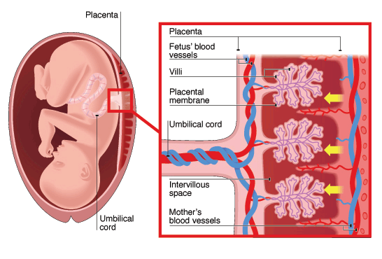

- Outline how the structure of the placenta aids in its function.

- Explain the benefit of fetal villi in the intervillous space.

- List the substances that are exchanged from the mother’s blood to the fetus’ and identify the blood vessel used to transport the substances to the fetus.

- List the substances that are exchanged from the fetus’ blood to mother’s blood, and identify the blood vessel that transports these substances to the placenta.

11.4.U8 Estrogen and progesterone are secreted by the placenta once it has formed.

- The placenta takes over hormonal control from what structure at week 10-12 of pregnancy?

- State the hormones secreted by the placenta during pregnancy.

- Outline the role of the placental hormones in maintaining pregnancy.

11.4.U9 Birth is mediated by positive feedback involving estrogen and oxytocin.

- Outline how the birth process is initiated by estrogen.

- Explain what is meant by a positive feedback loop.

- Explain the role of muscle contractions and oxytocin play in the positive feedback loop of the birth process.

- Explain why contractions continue for a short time after the birth of the baby.

11.4.A1 The average 38-week pregnancy in humans can be positioned on a graph showing the correlation between animal size and the development of the young at birth for other mammals.

- Define gestation.

- What are the two main factors that determine the length of gestation?

- Distinguish between altricial and precocial mammals at the time of birth.

- Analyze the graph below and determine the relationship between gestation period and adult animal mass. What is the general rule shown in this graph? Are there exceptions?
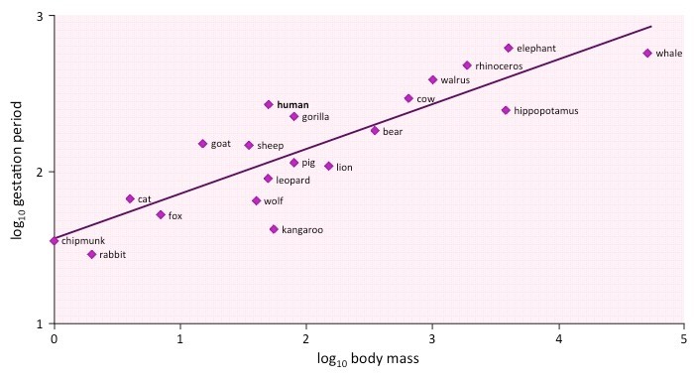

Nature of science: Assessing risks and benefits associated with scientific research—the risks to human male fertility were not adequately assessed before steroids related to progesterone and estrogen were released into the environment as a result of the use of the female contraceptive pill. (4.8)

- Outline how the high progesterone and estrogen content of the female contraceptive pill prevents pregnancy.

- Describe problems estrogen polluted water could cause to human fertility.

