**Topic 11.3 (AHL) – The Kidney and Osmoregulation**

**Understandings, Applications and Skills** (This is what you will be assessed on)

|  |  |
| --- | --- |
|  | **Statement** |
| 11.3.U1 | Animals are either osmoregulators or osmoconformers. |
| 11.3.U2 | The Malpighian tubule system in insects and the kidney carry out osmoregulation and removal of nitrogenous wastes. |
| 11.3.U3 | The composition of blood in the renal artery is different from that in the renal vein. |
| 11.3.U4 | The ultrastructure of the glomerulus and Bowman’s capsule facilitate ultrafiltration. |
| 11.3.U5 | The proximal convoluted tubule selectively reabsorbs useful substances by active transport. |
| 11.3.U6 | The loop of Henle maintains hypertonic conditions in the medulla. |
| 11.3.U7 | ADH controls reabsorption of water in the collecting duct |
| 11.3.U8 | The length of the loop of Henle is positively correlated with the need for water conservation in animals. |
| 11.3.U9 | The type of nitrogenous waste in animals is correlated with evolutionary history and habitat. |
| 11.3.A1 | Consequences of dehydration and overhydration. |
| 11.3.A2 | Treatment of kidney failure by hemodialysis or kidney transplant. |
| 11.3.A3 | Blood cells, glucose, proteins and drugs are detected in urinary tests. |
| 11.3.S1 | Drawing and labelling a diagram of the human kidney. |
| 11.3.S2 | Annotation of diagrams of the nephron. [The diagram of the nephron should include glomerulus, Bowman’s capsule, proximal convoluted tubule, loop of Henle, distal convoluted tubule; the relationship between the nephron and the collecting duct should be included.] |

**Recommended resources:**

Mrs. Tyler’s Website

Bioninja

Allott, Andrew. *Biology: Course Companion.* S.l.: Oxford UP, 2014. Print.

1. Define excretion. What waste product is produced as a result?
2. Outline the two main functions of the excretory system.
3. The type of nitrogenous waste that an organism excretes corresponds to what?
4. Explain the differences between ammonia, urea, and uric acid as nitrogenous wastes (including toxicity and water requirements) and which type of organism (aquatic vs terrestrial) secretes it.
5. Define osmolarity.
6. Animals are classified as either osmoregulators or osmoconformers based on how they manage their internal osmotic concentrations. What is the difference between the two, and what are the pros and cons of each?
7. Explain how insects remove their nitrogenous wastes and regulate water using Malpighian tubules.

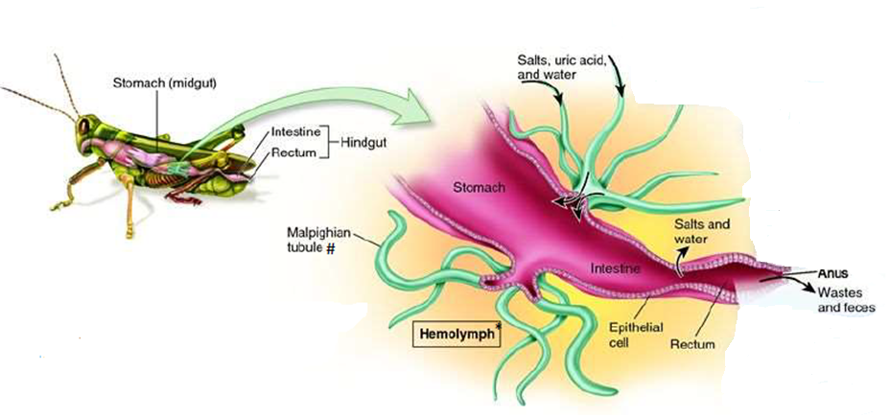

1. What is hemolymph?
2. Mammals use kidneys as the blood’s filtration and water balancing system, removing metabolic wastes for excretion. Label each of the following structures of the kidney below, and describe the function of each.

a. Renal artery

b. Renal vein

c. Cortex

d. Medulla

e. Renal pelvis

f. Ureter

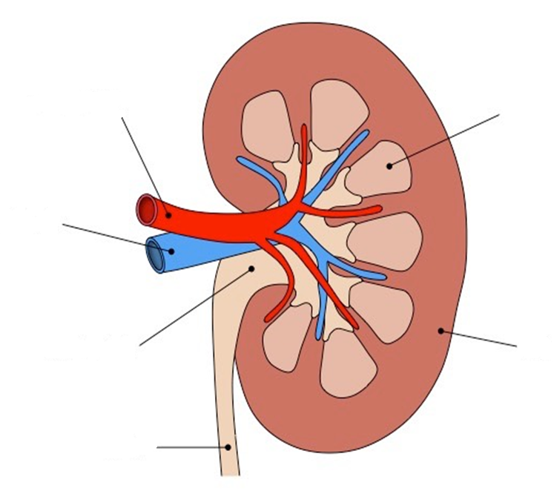

1. The kidney causes changes in the composition of blood. Describe how the filtered blood leaving the kidney in the renal vein will compare with the unfiltered blood that enters the kidney in the renal artery.
2. What components should the urine in the ureter contain once the blood has been filtered?
3. The functional unit of the kidney is the ________________________________. What does the nephron do?
4. Label each component of the nephron below:

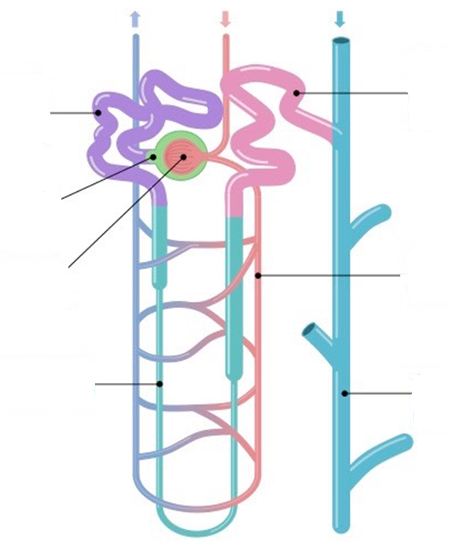

**Steps of Urine Formation**

1. Annotate the labelled diagram above with the major task in urine formation each part of the nephron is responsible for. Tasks include: ultrafiltration, selective reabsorption, osmoregulation (salt gradient), and osmoregulation (water retention).
2. Outline the Four Key Stages of urine formation.

**Step 1: Ultrafiltration**

1. The first structure blood filters through in the nephron to form filtrate is ___________________________ ____________________________.
2. 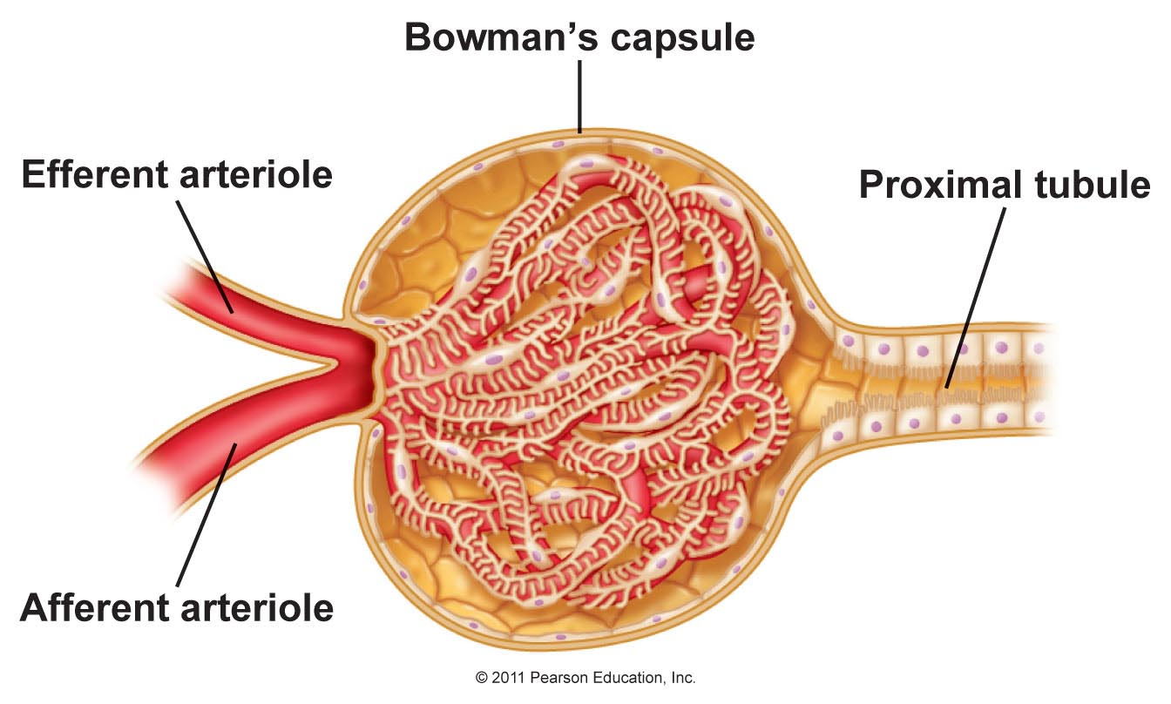Describe the structure of each of the following components of Bowman’s capsule, and their role in the process of ultrafiltration:

Podocytes

Glomerulus

A. Bowman’s capsule

B. glomerulus

C. afferent arteriole

D. efferent arteriole

E. podocytes

F. vasa recta

1. Explain the structural adaptation of Bowman’s capsule that allow small molecules to be filtered through to form filtrate that will travel through the nephron. Your answer should include the role of the podocytes, basement membrane, and fenestrations in blood vessels.
2. What molecules will NOT become part of the filtrate as blood is initially filtered in glomerulus. Why?
3. Ultrafiltration relies on high pressure within the glomerulus to force small molecules through the capillaries to form the filtrate. Explain how this process works, and what creates this high pressure inside the glomerulus.
4. Summarize the process of ultrafiltration according to the IB markscheme.

**Step 2: Selective Reabsorption**

1. Once the filtrate leaves Bowman’s Capsule, it enters the ______________________________________
2. What happens here?
3. What types of things will be reabsorbed back into the blood here?
4. Outline the characteristics of the proximal convoluted tubule cells that allow selective reabsorption to be efficient.
5. Label the apical and basolateral membranes of the PCT cells in the diagrams below:

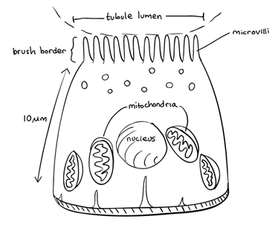 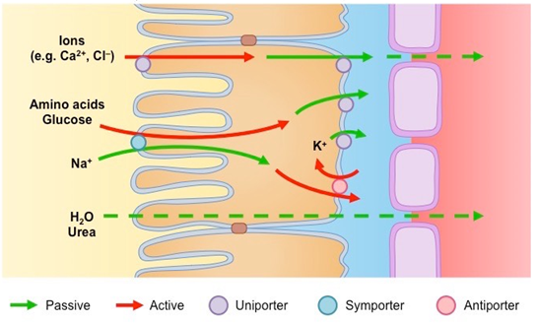

1. Explain how substances are taken up by the PCT cells to be moved back into the blood stream.

**Step 3: Osmoregulation (Establishing Salt Gradient)**

1. Once the filtrate leaves the PCT, it enters the _____________________________________________.
2. Outline the two components of osmoregulation.
3. State which section of the kidney each portion of the nephron is found in: cortex or medulla:

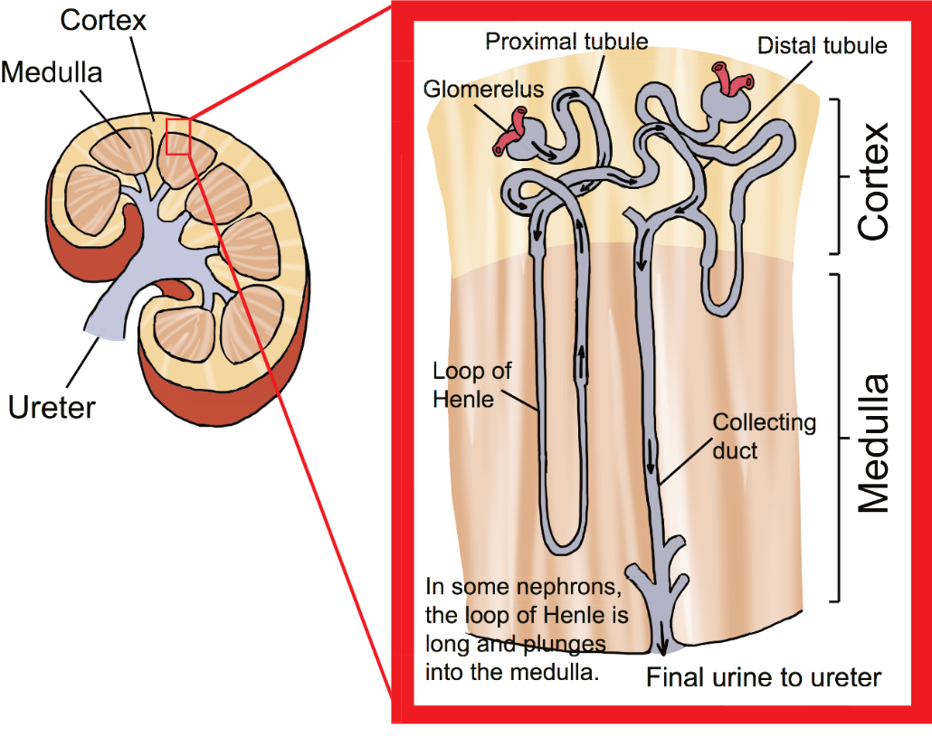

a. glomerulus -

b. proximal convoluted tubule -

c. loop of Henle -

d. distal convoluted tubule -

e. collecting duct -

1. Which two parts of the nephron are involved in osmoregulation? Based on where they are located in the kidney, which part is most responsible for osmoregulation: the cortex or the medulla?
2. The whole goal of the loop of Henle is to do what? How is this important in water uptake from the collect duct as filtrate continues through the nephron?
3. Label the descending and ascending loop in the diagram of the loop of Henle below, and annotate it to show what it is permeable to (what leaves) and what it is impermeable to (does not leave).

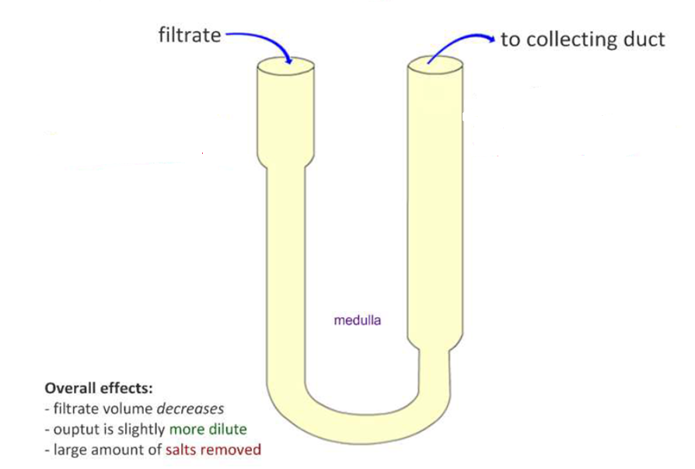

1. Explain how salts and water leave the loop of Henle to establish the salt gradient. You should include how the counter-current flow of filtrate helps this process.

**Step 4: Selective Reabsorption**

1. Once the filtrate leaves the loop of Henle, it enters the _______________________________________ _________________________________.
2. What happens here?

**Step 5: Osmoregulation (Water Reuptake)**

1. What the filtrate leaves the DCT, it enters the ______________________________________________.
2. What two things will determine how much water is drawn out of the filtrate in the collecting duct to be reabsorbed back into the blood?
3. The blood in the capillaries of the vasa recta surrounding the nephron moves in which direction compared to the collecting duct? How does this help facilitate the movement of water from the collecting duct into the capillaries?
4. Which hormone is responsible for determining how much water is released by the collecting duct? What does that acronym stand for? When is it secreted from the pituitary?
5. Explain how the presence or absence of ADH impacts the permeability of the collecting duct to water.
6. Summarize the process of osmoregulation in the loop of Henle and in the collecting duct according to the IB markscheme.

**SUMMARY OF URINE FORMATION**

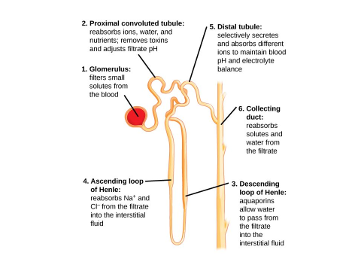



**Importance of Water Regulation**

1. Why is water regulation so important? What might happen to animal cells if placed in a hypotonic or hypertonic solution?
2. Explain how the length of the loop of Henle is correlated with water conservation.
3. Animals with a long loop of Henle are likely found in _________________________ environments.
4. How does the length of the loop of Henle correlate with how concentrated urine can become?
5. Outline the consequences of being dehydrated.
6. Outline the consequences of being overhydrated.

**Kidney Disease**

1. What is kidney disease?
2. How can kidney disease be detected?
3. Kidneys prevent the excretion of blood cells and proteins (during ultrafiltration) as well as glucose (selective reabsorption). What might the presence of each of these in the urine indicate:

A. glucose

B. proteins

C. blood cells

D. drugs/toxins

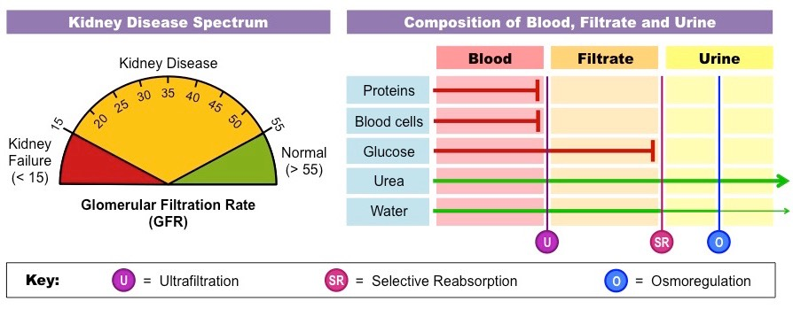

1. What are the two ways that kidney failure can be treated?
2. Explain how hemodialysis works.
3. Explain the process of kidney transplantation, and things that need to be considered to make sure the transplant is not rejected.