Topic 11.2 (AHL) – Movement

Understandings, Applications and Skills (This is what you will be assessed on)

 | Statement | Guidance
11.2.U1 | Bones and exoskeletons provide anchorage for muscles and act as levers.
11.2.U2 | Synovial joints allow certain movements but not others.
11.2.U3 | Movement of the body requires muscles to work in antagonistic pairs.
11.2.U4 | Skeletal muscle fibres are multinucleate and contain specialized endoplasmic reticulum.
11.2.U5 | Muscle fibres contain many myofibrils.
11.2.U6 | Each myofibril is made up of contractile sarcomeres.
11.2.U7 | The contraction of the skeletal muscle is achieved by the sliding of actin and myosin filaments.
11.2.U8 | ATP hydrolysis and cross bridge formation are necessary for the filaments to slide.
11.2.U9 | Calcium ions and the proteins tropomyosin and troponin control muscle contractions.
11.2.A1 | Antagonistic pairs of muscles in an insect leg.
11.2.S1 | Annotation of a diagram of the human elbow. | Elbow diagram should include cartilage, synovial fluid, joint capsule, named bones and named antagonistic muscles.
11.2.S2 | Drawing labelled diagrams of the structure of a sarcomere. Drawing labelled diagrams of the structure of a sarcomere should include Z lines, actin filaments, myosin filaments with heads, and the resultant light and dark bands.
11.2.S3 | Analysis of electron micrographs to find the state of contraction of muscle fibres. | Measurement of the length of sarcomeres will require calibration of the eyepiece scale of the microscope.

Recommended resources:
Mrs. Tyler’s Website
Bioninja
Allott, Andrew. Biology: Course Companion. S.l.: Oxford UP, 2014. Print.

11.2.U1 Bones and exoskeletons provide anchorage for muscles and act as levers.

- State the role of each of the following systems in movement:

A. Skeletal system –

B. Muscular system –

C. Nervous system –

- Define the term lever. How do bones act as levers?

- Outline the role of each of the following in movement:

A. Bones

B. Joints

C. Muscles

D. Tendons

E. Ligaments

1.2.U3 Movement of the body requires muscles to work in antagonistic pairs.

- Explain why muscles are regarded as being antagonistic.

- Give two examples of an antagonistic pair of muscles in humans: one in the arm and one in the leg.

- Define the terms flexion and extension.

- Can you suggest the benefits of having a pair of antagonistic muscles rather than a single muscle?

11.2.A1 Antagonistic pairs of muscles in an insect leg.

- State the name and roles of the two muscle groups in the leg of insects. How are they specialized for jumping?

11.2.U2 Synovial joints allow certain movements but not others.
- Outline the role of joints in the body, including where they are found.

- Label and annotate the diagram of a synovial joint below, stating the function of the following structures:

A. joint capsule
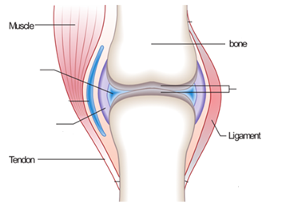

B. synovial fluid

C. cartilage

- Distinguish between the range of movement allowed by ‘hinge’ and ‘ball and socket’ joints?

- List 2 examples of hinge joints and 2 examples of ball-and-socket joints, and where they are found in the body.

11.2.S1 Annotation of a diagram of the human elbow.
- Label and annotate the functions of the different structures in the human elbow below.

Structure | Function
Biceps
Triceps
Humerus
Radius/Ulna
Cartilage
Synovial Fluid
Joint Capsule
Tendons
Ligaments
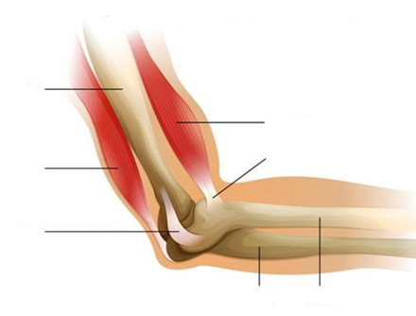

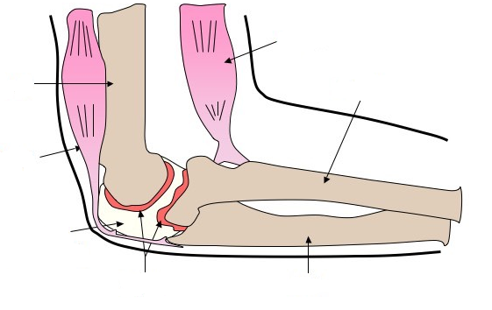

11.2.U4 Skeletal muscle fibres are multinucleate and contain specialized endoplasmic reticulum. AND 11.2.U5 Muscle fibres contain many myofibrils.

- Describe several characteristics of skeletal (striated) muscle.

- Outline the function/organization of the specialised structures that make up muscle fiber cells.

A. Fascicle -

B. Muscle fiber cell -

C. Myofibril -

D. Sarcomere -

E. Sarcolemma -

F. Sarcoplasmic reticulum -

G. Mitochondria -
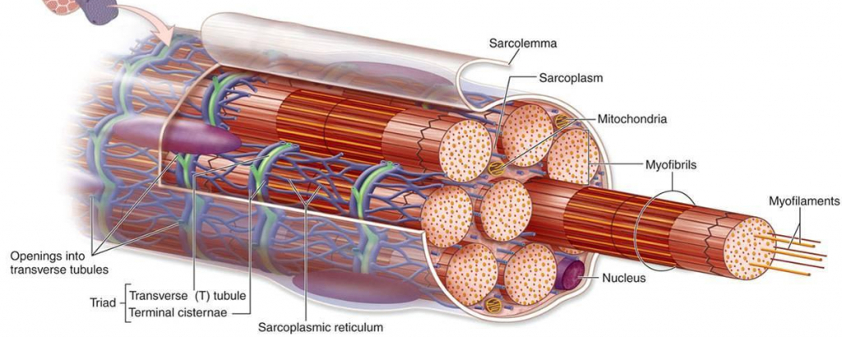

11.2.U6 Each myofibril is made up of contractile sarcomeres. AND 11.2.S2 Drawing labelled diagrams of the structure of a sarcomere.

- Label the following parts of the sarcomere on the diagrams below, and state the function of each piece/what it is composed of.

a. Myosin –

b. Actin –

c. Z disc –

d. A band –

e. I band –

f. H zone –

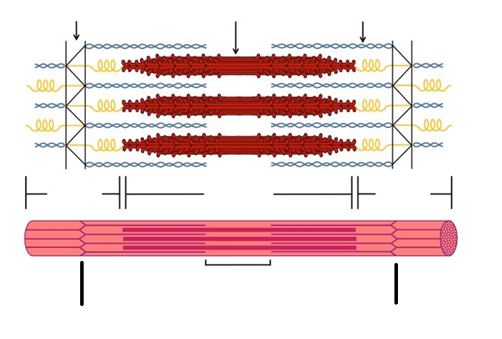
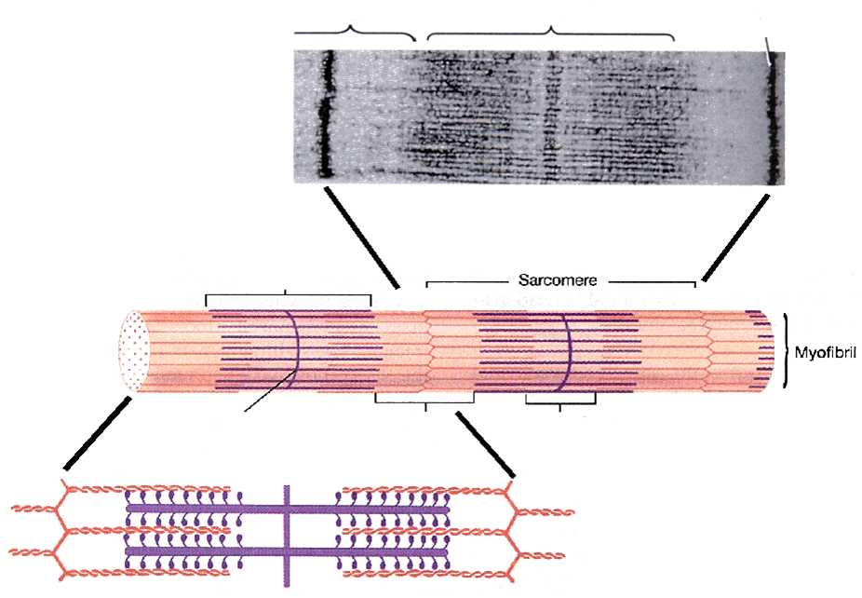

- Myosin is a motor protein that contains heads that walk along the ______________________. The head is also where ________________________________________________ occurs to supply the energy needed for the sarcomeres to contract.

- Actin contains binding sites for myosin heads, but they are covered/uncovered by the following two proteins. Explain how they play a role in contraction:

A. troponin –

B. tropomyosin –

*****MAKE SURE YOU CAN DRAW AND ANNOTATE ALL MAJOR COMPONENTS OF A SARCOMERE, WITH MYOSIN BEING THICKER THAN ACTIN FILAMENTS*****
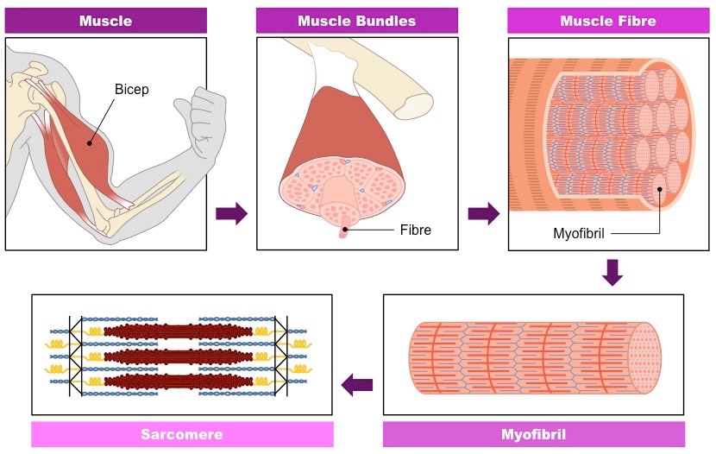

11.2.U7 The contraction of the skeletal muscle is achieved by the sliding of actin and myosin filaments.
11.2.U8 ATP hydrolysis and cross bridge formation are necessary for the filaments to slide.
11.2.U9 Calcium ions and the proteins tropomyosin and troponin control muscle contractions.

- The process of muscle contraction is referred to as the sliding filament theory. Why is this?

- Explain in detail how the sliding of actin and myosin filaments is achieved, referring to cross-bridges, ATP, tropomyosin, and troponin in your explanation. List and describe IN DETAIL each of the five steps.

1. ________________________________________ stimulates ________________________________

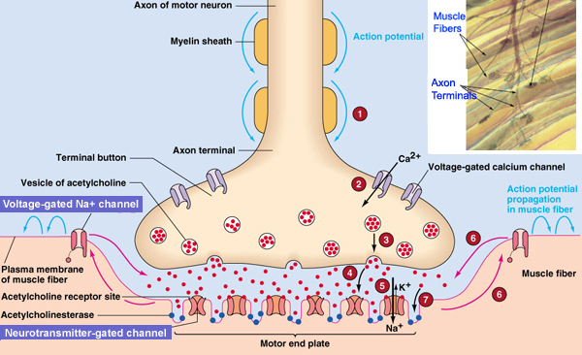

2. Actin/Myosin ________________________________ ___________________________

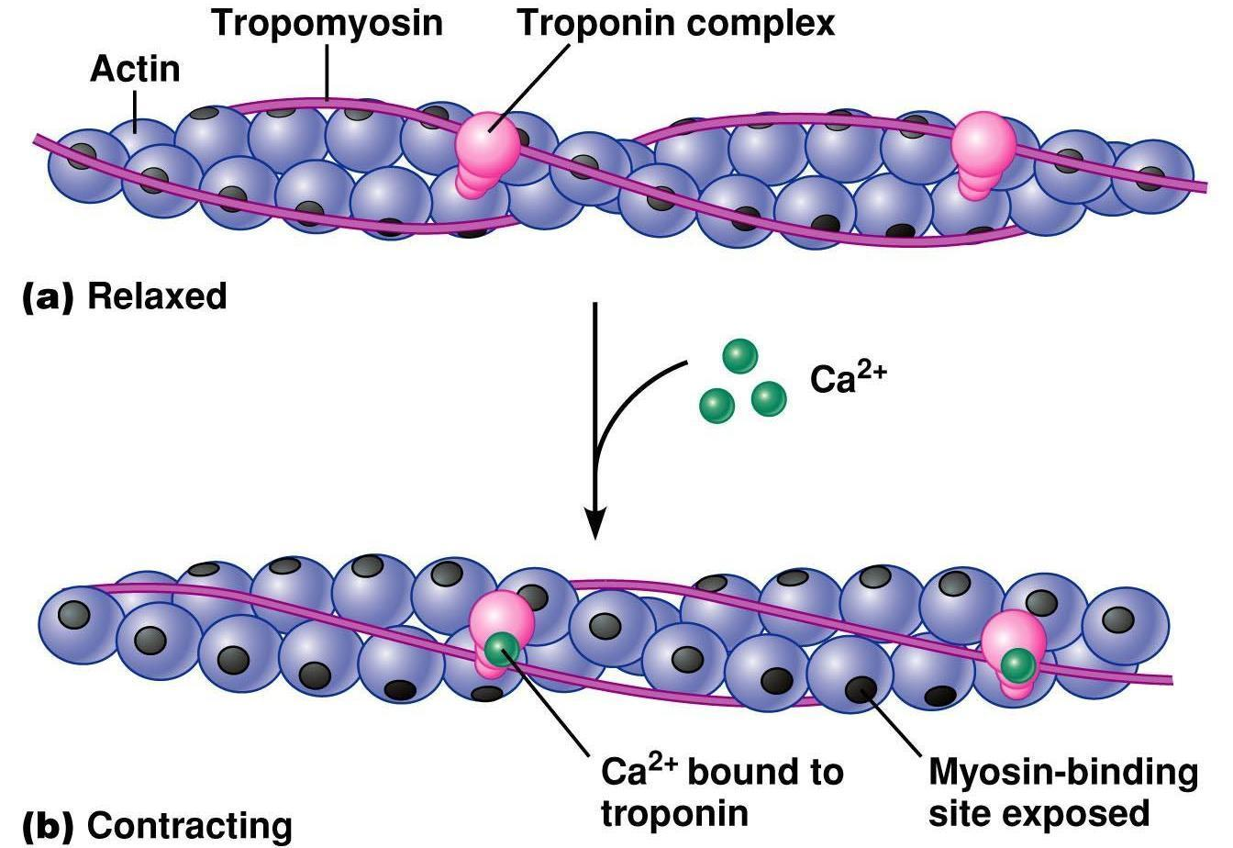

3. _________________________ of Actin and Myosin

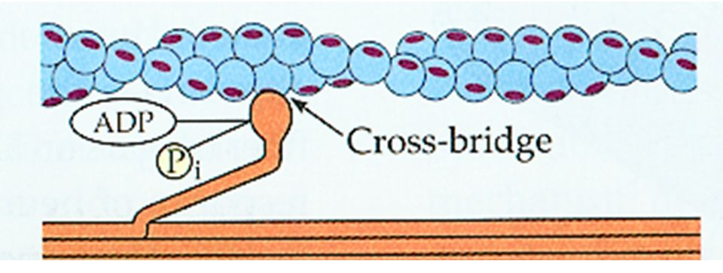

4. ___________ ___________________________

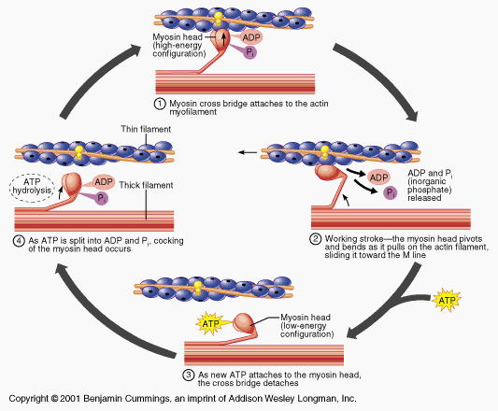
5. Sarcomere ______________________________

11.2.S3 Analysis of electron micrographs to find the state of contraction of muscle fibres.
- Label the 2 diagrams of sarcomeres to show which myofibril is in state of contraction vs relaxation.

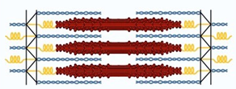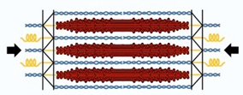

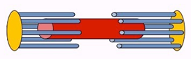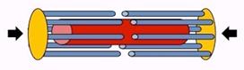

- How can you tell if the sarcomere is contracted or relaxed?

- Label the electron micrograph of sarcomeres to show which myofibril is in state of contraction vs relaxation.

- Can you identify and label electron micrographs with the same information in your diagram from 11.2.U6?

Nature of science: Developments in scientific research follow improvements in apparatus - fluorescent calcium ions have been used to study the cyclic interactions in muscle contraction. (1.8)

- State the name and origin of the protein to which calcium ions binds causing it to fluoresce.

- State the property of the protein that makes it suitable for studying muscle contraction.

- Outline the findings of the experiment and how they helped to identify the role of calcium ions in muscle contraction.

