Topic 11.1 (AHL) – Antibody Production and Vaccines

Understandings, Applications and Skills (This is what you will be assessed on)

 | Statement | Guidance
11.1.U1 | Every organism has unique molecules on the surface of its cells.
11.1.U2 | Pathogens can be species-specific although others can cross species barriers.
11.1.U3 | B lymphocytes are activated by T lymphocytes in mammals. | Limit the immune response to mammals.
11.1.U4 | Activated B cells multiply to form clones of plasma cells and memory cells.
11.1.U5 | Plasma cells secrete antibodies.
11.1.U6 | Antibodies aid the destruction of pathogens.
11.1.U7 | White cells release histamine in response to allergens.
11.1.U8 | Histamines cause allergic symptoms.
11.1.U9 | Immunity depends upon the persistence of memory cells.
11.1.U10 | Vaccines contain antigens that trigger immunity but do not cause the disease.
11.1.U11 | Fusion of a tumour cell with an antibody-producing plasma cell creates a hybridoma cell.
11.1.U12 | Monoclonal antibodies are produced by hybridoma cells.
11.1.A1 | Smallpox was the first infectious disease of humans to have been eradicated by vaccination.
11.1.A2 | Monoclonal antibodies to HCG are used in pregnancy test kits.
11.1.A3 | Antigens on the surface of red blood cells stimulate antibody production in a person with a different blood group.
11.1.S1 | Analysis of epidemiological data related to vaccination programmes.

Recommended resources:
Mrs. Tyler’s Website
Bioninja
Allott, Andrew. Biology: Course Companion. S.l.: Oxford UP, 2014. Print.
- All cells have a “unique” marker embedded in the cell membrane. What is the marker on cells recognized as ‘self’ and how are these treated by the immune system?

- Describe what an antigen is and how this is related to the immune response.

- Explain why blood transfusions are not compatible between certain blood groups.

- Which blood type is the universal acceptor? Why?

- Which blood type is the universal donor? Why?

- Outline why a person with type O blood can only receive blood from others with type O.
- Define immunity.

- Compare active and passive immunity.

- Pathogens are any agent that can cause disease. Qualify the statement “Diseases only infect specific species.”

- Define the term zoonosis and give some examples.

- List four major mechanisms of disease transmission.

Mammalian Immune Response:

- Define non-specific immunity.

- Outline how skin and mucus membranes play a role in non-specific immunity.

- How is specific immunity different from non-specific immunity?

- Outline the role of lymphocytes in the mammalian immune response.

- Explain the steps involved in the mammalian immune response. How are antibodies are produced and respond to infection by a pathogen?

A. Outline antigen presentation and T lymphocyte activation.

B. Outline B lymphocyte activation.

C. Outline plasma cell and antibody production.

D. Outline pathogen destruction.

E. Outline how the formation of memory cells leads to immunity.

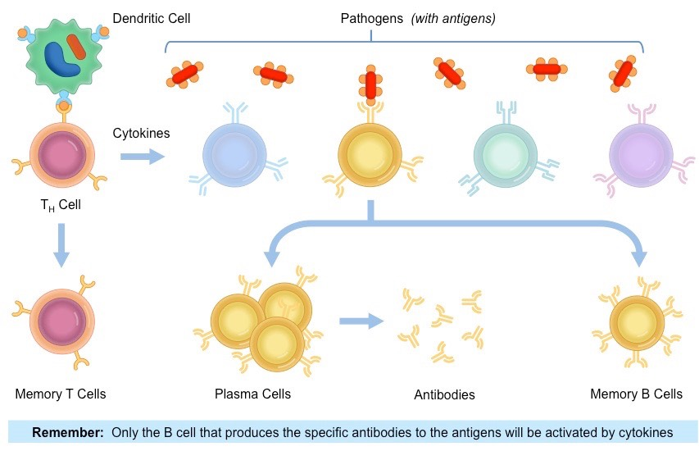

- Antibodies are Y-shaped proteins. How are the many different kinds of antibodies produced?

- Define opsonisation as it relates to antibodies enhancing the immune response.

- List the five ways antibodies are able to destroy pathogens.

Allergic Reactions

- Define allergen.

- Outline the two stages of an allergic response: sensitization and allergic reaction.

- Explain the role of histamines in aiding the allergic response.

- List some of the symptoms associated with the allergic response.

Vaccination

- Outline how the formation of memory cells leads to immunity.

- What is the purpose of vaccination?

- What do vaccines contain, and how can they be administered?

- Outline how vaccination leads to immunity.

- Explain why booster shots are needed periodically after the original vaccination.

- Outline the purpose of vaccination programs.

- Define herd immunity.

- What was the first disease to be successfully eradicated by vaccinations, and why was this successful?

- What organization is responsible from monitoring disease incidence and immunizations in different countries?

- Nature of science: Consider ethical implications of research - Jenner tested his vaccine for smallpox on a child. Outline how Jenner’s trials would be in breach modern day ethical concerns for testing drugs and vaccines.

- Describe epidemiology, and what this field of science investigates.

- Make sure you know this skill: Analysis of epidemiological data related to vaccination programmes. Can you analyse epidemiological data to spot trends and suggest underlying reasons?

Monoclonal Antibodies

- Define monoclonal antibodies and what they are used for.

- Outline the production of monoclonal antibodies.

- Define hybridoma.

- List some examples of how monoclonal antibodies can be used for treatment purposes.

- Briefly explain why pregnancy tests look for the presence of HCG.

- Outline how monoclonal antibodies can be used in pregnancy tests to detect the presence of HCG.

