Topic 10.3 (AHL) – Evolution (Gene Pools and Speciation)

Understandings, Applications and Skills (This is what you will be assessed on)

 | Statement | Guidance
10.3.U1 | A gene pool consists of all the genes and their different alleles, present in an interbreeding population.
10.3.U2 | Evolution requires that allele frequencies change with time in populations.
10.3.U3 | Reproductive isolation of populations can be temporal, behavioural or geographic.
10.3.U4 | Speciation due to divergence of isolated populations can be gradual.
10.3.U5 | Speciation can occur abruptly. | Punctuated equilibrium implies long periods without appreciable change and short periods of rapid evolution.
10.3.A1 | Identifying examples of directional, stabilizing and disruptive selection.
10.3.A2 | Speciation in the genus Allium by polyploidy.
10.3.S1 | Comparison of allele frequencies of geographically isolated populations.

Recommended resources:
Mrs. Tyler’s Flipped Videos
Allott, Andrew. Biology: Course Companion. S.l.: Oxford UP, 2014. Print.

Link to awesome natural selection and speciation video:

http://www.youtube.com/watch?v=hOfRN0KihOU

Flipped Video: Evolution: Changing the Gene Pool (Parts 1 and 2)

10.3.U1 A gene pool consists of all the genes and their different alleles, present in an interbreeding population.

- Define evolution.

- Define the term gene pool.

- What does a large indicate, and why is this more beneficial for evolution?

- Explain what is meant by the term allele frequency.

10.3.U2 Evolution requires that allele frequencies change with time in populations.

- Finish the following phrase: Evolution occurs when there is a change…

- Outline why for evolution to occur a change in allele frequencies, within a population, is necessary.

- Below are the 5 ways in which a change to the frequency of alleles in a gene pool, and thus evolution, can occur. Describe each in detail as to how it relates to allele frequency changes.

a. Mutation –

b. Gene Flow –

i. How is gene flow important for maintaining genetic diversity in populations?

c. Sexual Reproduction –

d. Genetic Drift –

i– Which size populations are most affected by genetic drift?

ii -Describe what a population bottleneck is, and how this affects genetic diversity.

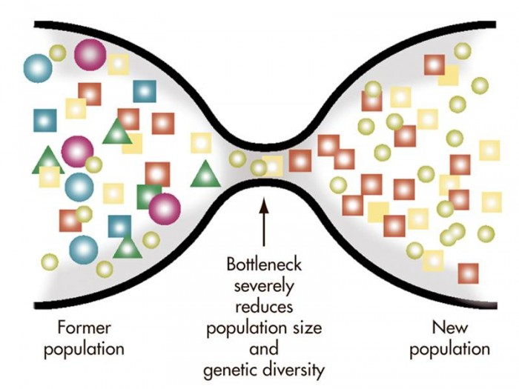

iii – Describe what the founder effect is, and how this influences genetic diversity

e. Natural Selection -

Flipped Video: Charles Darwin

- Complete the statement :_____________________________ ____________________________ is known as the founder of modern day evolutionary theory based on his discoveries from his voyage aboard the ____________ ________________________ to the ________________________________ _______________________.

- Describe the adaptation present in the Galapagos finches that Darwin observed, and how this relates to the theory of natural selection.

- Define natural selection as it was presented in Darwin’s book On the Origin of Species.

- True or False: Evolution occurs amongst populations, NOT individuals.
- Describe what is meant by the phrase ‘Descent with Modification.’

Flipped Video: Natural Selection

- Below, list and describe the 4 tenets of the theory of natural selection proposed by Darwin:

- What are some of the sources of genetic variation that drive evolution?

- Define the term fitness.

- Why is natural selection also called “survival of the fittest?”

Flipped Video: Three Types of Natural Selection

10.3.A1 Identifying examples of directional, stabilizing and disruptive selection.

- Complete the information below for Stabilizing Selection:

A. Which phenotype is favored?

B. Description

C. What is environment like?

D. Example:

- Complete the information below for Disruptive Selection:

A. Which phenotype is favored?

B. Description

C. What is environment like?

D. Example:

- Complete the information below for Directional Selection:

A. Which phenotype is favored?

B. Description

C. What is environment like?

D. Example:

- Label the following graphs as stabilizing, disruptive, or directional selection.

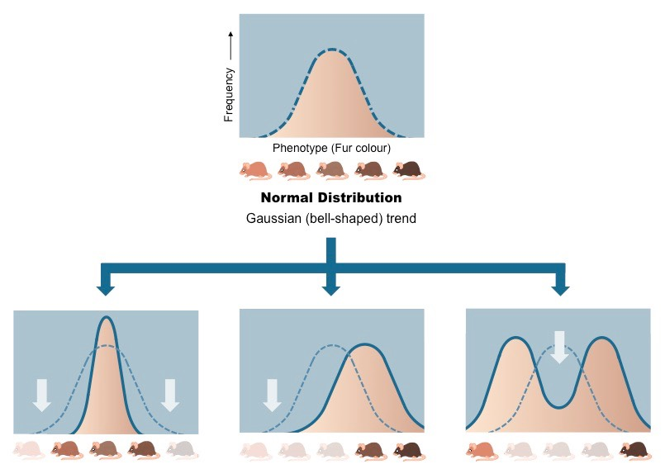

Flipped Video: Speciation (Parts 1 and 2)

- Define speciation. When is a new species officially formed?

- Define allopatric speciation. What is the driving force?

- Describe geographic isolation and how this can lead to the formation of separate species.

- Define sympatric speciation. What is the driving force?

Nature of science: Looking for patterns, trends and discrepancies - patterns of chromosome number in some genera can be explained by speciation due to polyploidy. (3.1) AND 10.3.A2 Speciation in the genus Allium by polyploidy.

- One mode of reproductive isolation that can lead to the formation of a new species is through polyploidy. Compared to the terms haploid and diploid describe what is meant by the term polyploidy.

- Outline how polyploidy can occur.

- True or False: Polyploid individuals can mate with other polyploids to produce fertile offspring, but cannot mate with their diploid parents. EXPLAIN WHY OR WHY NOT.

- Polyploidy is quite common in plants.
  - Explain why polyploidy is more common in plants than animals.

  - Describe why a polyploid plant can have a selective advantage over diploid rivals.

- Polyploidy can lead to speciation, as individuals with different numbers of chromosomes cannot interbreed.
A. Name two plant groups that commonly produce polyploids.

B. State two examples of different species found in the plant genus Allium and the number of chromosome of each species.

10.3.U3 Reproductive isolation of populations can be temporal, behavioural or geographic.

- Define Reproductive Isolation.

- Compare and contrast prezygotic and postzygotic barriers.

- Outline the mechanism by which populations can be reproductively isolated giving examples for each mechanism.
  - Temporal isolation

  - Behavioural isolation

  - Geographic isolation

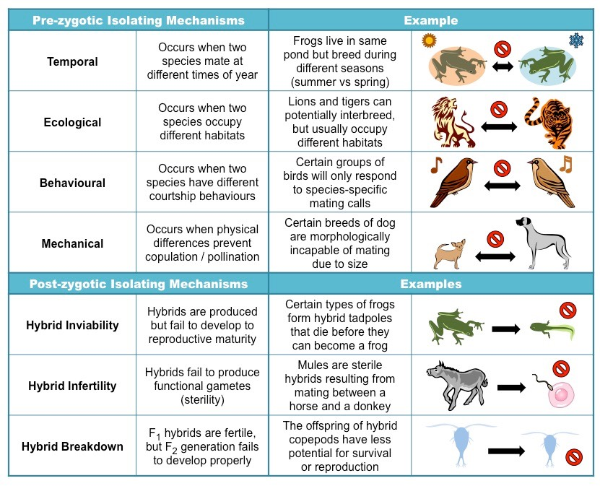

10.3.U4 Speciation due to divergence of isolated populations can be gradual.
10.3.U5 Speciation can occur abruptly.

- Label the following graphs as either showing gradualism or punctuated equilibrium.
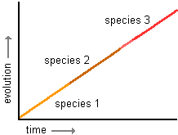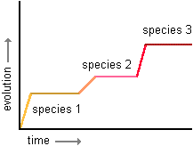

- Complete the table to distinguish between the different rates at which speciation can occur.

Viewpoint

Rate of Speciation | Gradual | Abrupt
Description
Evidence to support this view

