Topic 10.2 (AHL) – Genetics

Understandings, Applications and Skills (This is what you will be assessed on)

 | Statement | Guidance
10.2.U1 | Gene loci are said to be linked if on the same chromosome.
10.2.U2 | Unlinked genes segregate independently as a result of meiosis.
10.2.U3 | Variation can be discrete or continuous.
10.2.U4 | The phenotypes of polygenic characteristics tend to show continuous variation.
10.2.U5 | Chi-squared tests are used to determine whether the difference between an observed and expected frequency distribution is statistically significant.
10.2.A1 | Morgan’s discovery of non-Mendelian ratios in Drosophila.
10.2.A2 | Completion and analysis of Punnett squares for dihybrid traits. | Alleles are usually shown side by side in dihybrid crosses, for example, TtBb.
10.2.A3 | Polygenic traits such as human height may also be influenced by environmental factors.
10.2.S1 | Calculation of the predicted genotypic and phenotypic ratio of offspring of dihybrid crosses involving unlinked autosomal genes.
10.2.S2 | Identification of recombinants in crosses involving two linked genes. | In representing crosses involving linkage, show genotypes as vertical pairs separated by horizontal lines representing the chromosomes.
10.2.S3 | Use of a chi-squared test on data from dihybrid crosses. | (THIS WILL BE DONE IN CLASS)

Recommended resources:
Mrs. Tyler’s Flipped Videos

Allott, Andrew. Biology: Course Companion. S.l.: Oxford UP, 2014. Print.

10.2.U2 Unlinked genes segregate independently as a result of meiosis.

- Mendel’s Law of Independent Assortment

- In which situation will two or more genes sort, and therefore segregate independently, of each other? (i.e. where must they be located?)

10.2.A2 Completion and analysis of Punnett squares for dihybrid traits.
10.2.S1 Calculation of the predicted genotypic and phenotypic ratio of offspring of dihybrid crosses involving unlinked autosomal genes.

- Distinguish between dihybrid and monohybrid crosses.

- When Mendel came upon his law of independent assortment, he was studying sweet-pea colour and shape. These traits are carried on separate chromosomes (unlinked!). The colour yellow (Y) is dominant over green (y). Smooth peas (S) are dominant over rough (s).

  - State the possible genotypes for the following phenotypes:
Yellow, Smooth |  | Green, Smooth
Green, Rough | yyss | Yellow, Rough

  - Use the Punnett grid to predict the ratio of phenotypes of offspring in a cross between two peas which are heterozygous for both genes (SsYy x SsYy).

 | SY | Sy | sY | sy
SY
Sy
sY
sy

Phenotype | Smooth Yellow | Smooth green | Rough Yellow | Rough Green
Ratio

- A researcher has some smooth yellow peas. He wants to find out if they are homozygous or heterozygous for these dominant characteristics, so he performs a test cross.

  - State the genotype and phenotype of the plant that must be used as the test cross.

Genotype: Phenotype:

  - Complete the Punnett square for this cross. Deduce the phenotype ratios expected in the following crosses.

    - If the yellow, round pea was heterozygous for both color and shape:

Genotype of yellow round pea:___________________
Phenotype
Ratio

    - If the yellow, round pea was homozygous for both color and shape:

Genotype of yellow round pea:___________________
Phenotype
Ratio

    - If the yellow, round pea was heterozygous for colour, homozygous for shape.

Genotype of yellow round pea:___________________

Phenotype
Ratio

    - If the yellow, round pea was homozygous for color, heterozygous for shape.

Genotype of yellow round pea:___________________

Phenotype
Ratio

  - During a cross, a student found 120 yellow-smooth and 124 green-smooth. Deduce the most likely genotype for the unknown pea. Explain your answer.

Flipped Video: Gene Linkage and Recombinants

10.2.U1 Gene loci are said to be linked if on the same chromosome.
10.2.S2 Identification of recombinants in crosses involving two linked genes.

- Mendel’s law of independent assortment makes the assumption that genes for a pair or group of traits are located on separate chromosomes, and therefore the presence of one allele in a gamete is not connected to the presence of another. However, with hundreds of genes per chromosome, it is likely that some genes will be physically linked and therefore alleles will be inherited together.

  - Define linkage groups.

  - State the consequence of gene linkage in terms of the movement of alleles in anaphase I of meiosis.

Linkage groups will not …

  - What is the only way the linked genes might be separated?

  - The following notation is used to represent linked genes located on the same chromosome. Using the notation, label the alleles you would expect to find on each of the chromosomes in a diploid cell.
l M

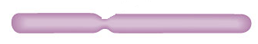
L m

Making careful observations—careful observation and record keeping turned up anomalous data that Mendel’s law of independent assortment could not account for. Thomas Hunt Morgan developed the notion of linked genes to account for the anomalies.

Nature of science: Looking for patterns, trends and discrepancies - Mendel used observations of the natural world to find and explain patterns and trends. Since then, scientists have looked for discrepancies and asked questions based on further observations to show exceptions to the rules. For example, Morgan discovered non-Mendelian ratios in his experiments with Drosophila.

10.2.A1 Morgan’s discovery of non-Mendelian ratios in Drosophila.

- Morgan’s experiments (1909 - 1914) with fruit flies produced results that could not be explained by Mendel’s work on heredity as it stood. Morgan’s key insight came after breeding a white-eyed male mutant with red eyed female flies.

a. What did he notice in the offspring?

b. What did he conclude from his findings with eye color inheritance?

- Other than determining sex-linkage with his eye color experiments, what was he also able to construct by looking at other mutant traits in Drosophila?

- Distinguish between autosomes and sex chromosomes. Distinguish between gene linkage (with autosomes) and sex linkage (on sex chromosomes).

10. What is the relationship that exists among distance between linked genes and crossover rate?

11. Based on the relationship above, which genes below are most likely to be separated by crossing over?

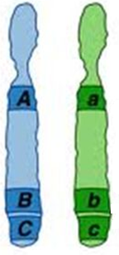

12. List the revisions to Mendelian theory made as a result of Morgan’s findings.

13. Why do we see less overall recombinants with linked genes?

Flipped Video: Polygenic Inheritance

10.2.U3 Variation can be discrete or continuous.
10.2.U4 The phenotypes of polygenic characteristics tend to show continuous variation.

14. Monogenic inheritance gives rise to a select few distinct phenotypes in offspring.
  - Define monogenic inheritance.

  - Provide examples of traits inherited in a monogenic manner in humans, flies, and peas.

  - Define discrete (discontinuous) variation.

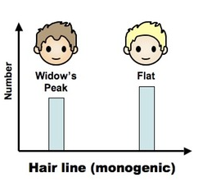

  - What type of graph is constructed if a trait shows discrete variation?

15. What happens to the number of potential phenotypes as the number of genes that control a single trait increases?

16. Polygenic inheritance gives rise to continuous variation.

- Define polygenic inheritance.

- Distinguish between polygenic inheritance and multiple alleles (blood types).

- List three human and one plant example of polygenic inheritance.

- Explain how polygenic inheritance gives rise to continuous variation within a population using skin colour as an example.

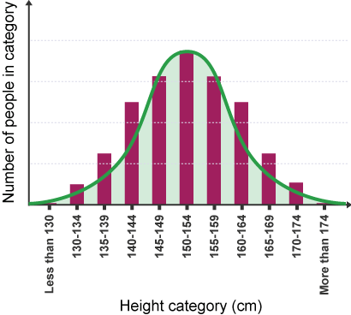

- What type of graph is made if a trait shows continuous variation?

10.2.A3 Polygenic traits such as human height may also be influenced by environmental factors.

- Most traits, including polygenetic traits such as height, maybe influenced by the environment of the organism. Complete the table to give examples of the ways in which this can happen.

Human Trait | Influencing Environment factors
Height
Skin color

