**Topic 10.1 (AHL) – Meiosis**

**Understandings, Applications and Skills** (This is what you will be assessed on)

|  |  |  |
| --- | --- | --- |
|  | **Statement** | **Guidance** |
| 10.1.U1 | Chromosomes replicate in interphase before meiosis. |  |
| 10.1.U2 | Crossing over is the exchange of DNA material between non-sister homologous chromatids. |  |
| 10.1.U3 | Crossing over produces new combinations of alleles on the chromosomes of the haploid cells. |  |
| 10.1.U4 | Chiasmata formation between non-sister chromatids can result in an exchange of alleles. |  |
| 10.1.U5 | Homologous chromosomes separate in meiosis I. |  |
| 10.1.U6 | Sister chromatids separate in meiosis II. |  |
| 10.1.U7 | Independent assortment of genes is due to the random orientation of pairs of homologous chromosomes in meiosis I. |  |
| 10.1.S1 | Drawing diagrams to show chiasmata formed by crossing over. | Diagrams of chiasmata should show sister chromatids still closely aligned, except at the point where crossing over occurred and a chiasma was formed. |

**Recommended resources:**

Mrs. Tyler’s Flipped Videos

Allott, Andrew. *Biology: Course Companion.* S.l.: Oxford UP, 2014. Print.

**Flipped Video: Cell Division (REVIEW FROM SL**)

1. Define homologous chromosomes.

2. Define the term diploid. What types of cells are diploid (2n)?

3. Define the term haploid. What types of cells are haploid (n)?

4. Briefly outline what happens during interphase.

5. Label the four stages of mitosis below.

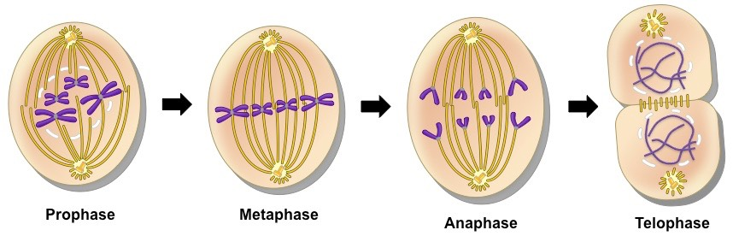

6. Define cytokinesis.

7. Fill out the chart below to compare and contrast mitosis and meiosis:

|  |  |  |
| --- | --- | --- |
|  | Mitosis | Meiosis |
| Number of daughter cells |  |  |
| Chromosome # (2n or n) |  |  |
| Number of divisions |  |  |
| Variation in offspring? |  |  |
| Type of daughter cell produced |  |  |
| Purposes of division |  |  |

**Flipped Video: Meiosis**

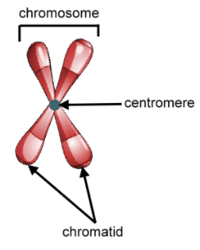

1. Define meiosis.

Label the diagram 🡪

**10.1.U1 Chromosomes replicate in interphase before meiosis.**

1. State which part of interphase chromosomes replicate in.

1. State the term used to refer to the replicated chromosomes – two identical copies of the chromosomes. (To avoid confusion the term chromosome is not used)
2. What is the name of the protein complex that joins sister chromatids together with their clone?

**10.1.U5 Homologous chromosomes separate in meiosis I.**

**10.1.U6 Sister chromatids separate in meiosis II.**

1. In each part of meiosis (I and II) the amount of DNA in the nucleus is reduced, but in different ways.
   1. What is separated during meiosis I?

* 1. Why is meiosis I referred to as the reduction division?

1. Briefly outline what happens in each stage of meiosis I:

a. Prophase I:

b: Metaphase I:

c. Anaphase I:

d. Telophase I:

6. Define the term crossing over. What does this lead to?

7. What stage of meiosis does crossing over occur in?

8. Define the term bivalent (aka tetrad).

9. In each part of meiosis (I and II) the amount of DNA in the nucleus is reduced, but in different ways.

* 1. What is separated during meiosis II?

* 1. Explain why Meiosis II is not classed as being a reduction division.

10. Briefly outline what happens in each stage of meiosis II:

a. Prophase II:

b: Metaphase II:

c. Anaphase II:

d. Telophase II:

11. What is produced at the end of meiosis?

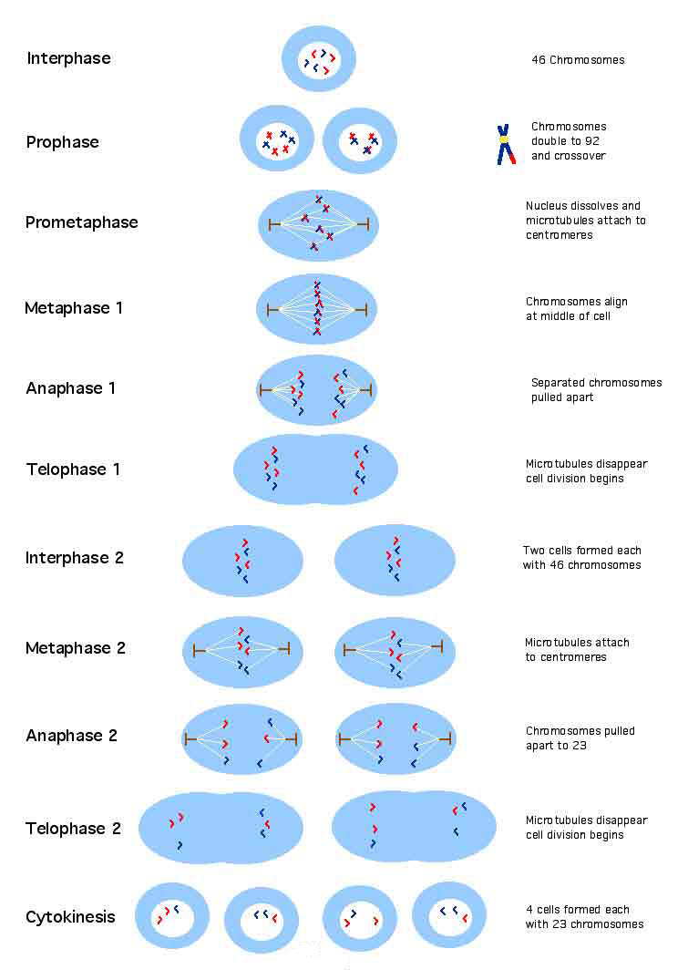

**Flipped Video: Sources of Genetic Variation in Meiosis**

12. What are the three main sources of genetic variation in meiosis? Briefly describe each.

10.1.U2 Crossing over is the exchange of DNA material between non-sister homologous chromatids.

10.1.U4 Chiasmata formation between non-sister chromatids can result in an exchange of alleles.

13. The process of crossing over occurs in three main steps: synapsis, chiasma formation, and separation.

a. Outline the process of synapsis. How do homologous chromosomes pair to prepare for crossing over?

b. Define the terms bivalent and tetrad.

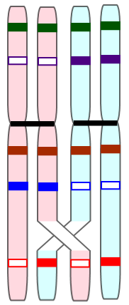

c. Define the term chiasmata and label it in the picture to the left.

14. Crossing over only occurs between _________________________________________ chromatids to shuffle genes.

**10.1.U3 Crossing over produces new combinations of alleles on the chromosomes of the haploid cells.**

15. Explain the effect of crossing over in terms of genetic diversity.

**10.1.S1 Drawing diagrams to show chiasmata formed by crossing over.**

16. Draw and label diagrams to show synapsis, chiasma formation and the separation that leads to recombination.

17. ‘Wildtype’is the term used to describe un-recombined (non-recombinant) chromatids. State the term is used to describe chromosomes that have undergone crossing over.

18. Label the recombinant chromatids in the diagram below illustrating the process of crossing over.

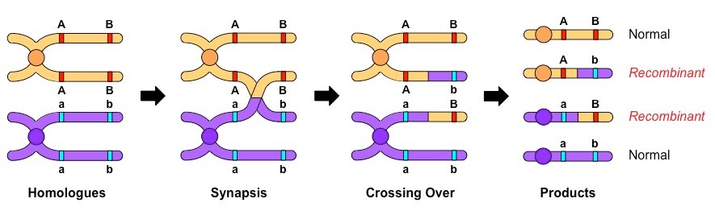

**10.1.U7 Independent assortment of genes is due to the random orientation of pairs of homologous chromosomes in meiosis I.**

19. Mendel made many advances in genetics through careful observation and statistical analysis.

a. State Mendel’s Law of Independent Assortment

b.Explain the link between the law of independent assortment and meiosis. What is the reason why Mendel observed independent assortment? During which phase of meiosis does this take place?

c.What assumption is made for this law to hold true? What are the only types of genes that assort independently?

20. Explain the difference between linked and unlinked genes

21. Identify in the diagram which genes are linked, and which are unlinked.



22. What is the formula used to predict how many possible unique gametes can be made through independent assortment?